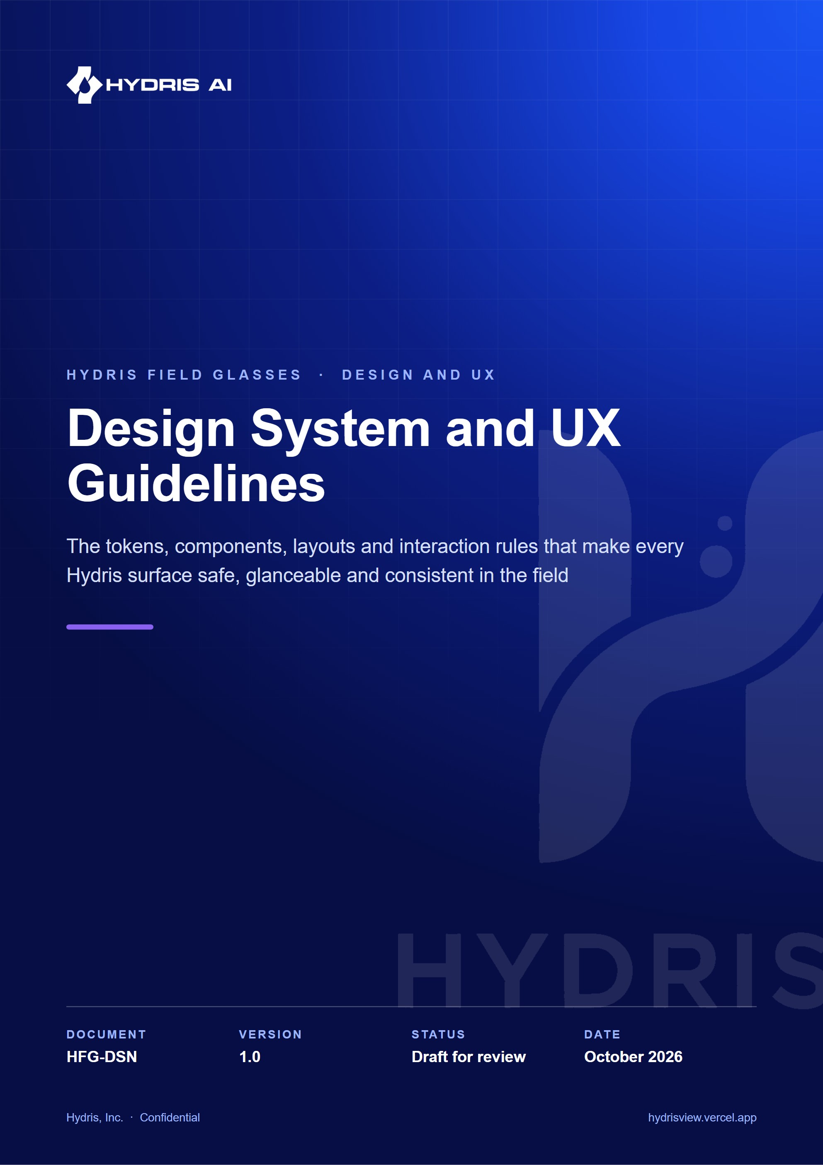
Document control
Document | Design System and UX Guidelines (HFG-DSN)
Version | 1.0
Status | Draft for review
Owner | Design, Hydris
Audience | Designers, front-end and Android engineers, product managers, QA, pilot customer reviewers
Product | Hydris Field Glasses: website, operator console, glasses app, Android app, API
Source of truth | docs/product/DESIGN_SYSTEM.md in tarun-km/hydrisview (this Word file is generated from it)
Classification | Confidential: Hydris, Inc. and named partners
Revision history
Version | Date | Author | Changes
1.0 | October 2026 | Design, Hydris | First edition: tokens and contrast audit per surface, component library, layout grids, interaction state machines, accessibility, content and governance

Contents
1 Design principles 5
1.1 Safety first 5
1.2 The one-glance rule 5
1.3 Advisory only 6
1.4 Never hide state 6
1.5 Dark first for the glasses 6
1.6 Consistency across surfaces 6
2 Design system architecture 7
3 Brand and colour system 9
3.1 Brand palette 9
3.2 Web neutral and surface tokens (dark and light) 9
3.3 Android tokens 10
3.4 HUD colour values 11
3.5 Severity and status colour mapping 11
3.6 Contrast audit 14
4 Typography 16
4.1 Typefaces 16
4.2 Web type scale 16
4.3 Android type scale 17
4.4 HUD type scale 17
5 Spacing, radius and elevation 19
5.1 Spacing 19
5.2 Radius 19
5.3 Elevation 19
6 Iconography 21
7 Component library 22
7.1 Component inventory 22
7.2 Cards 23
7.3 KPI tiles 24
7.4 Chips and badges 25
7.5 Buttons 25
7.6 Inputs and forms 26
7.7 Tables 26
7.8 Alarm rows 27
7.9 Charts 29
7.10 Empty, loading and error states 30
8 Data visualisation guidelines 32
9 Layout grids 33
9.1 Console desktop 33
9.2 Phone (glasses phone mode and Android) 34
9.3 HUD 600 by 600 37
9.4 UI profiles shape the layout 38
10 Navigation patterns 39
10.1 Console information architecture 39
10.2 Glasses app information architecture 40
10.3 Android app navigation 41
11 Interaction patterns 44
11.1 Input model 44
11.2 Voice first: "Hey Hydris" 44
11.3 Capture button and audit scan 46
11.4 Guided capture feedback 48
11.5 Back navigation 53
11.6 Alarm acknowledgement and lifecycle 54
11.7 Operator experience journey 55
12 Motion 57
13 Accessibility 58
13.1 Targets 58
13.2 Gloves, noise and outdoor light 58
13.3 Haptics (Planned) 58
14 Content and voice guidelines 59
15 Localisation 60
16 Dark and light themes 61
17 Design QA checklist 62
18 Governance and contribution 63
19 Future work 66

Hydris Field Glasses is used by people standing next to running pumps, aeration basins and chemical dosing skids, often wearing gloves, ear defenders and safety glasses, sometimes in bright sun and sometimes in a dark pump room. The design system exists so that every surface (the marketing website, the operator console, the glasses heads-up app, the browser simulator and the native Android app) shows plant state the same way, uses colour for the same meaning, and never asks an operator to read more than they can take in at a glance.
This document describes the system as it is built today, with every token and component traced to the file that defines it, and it marks the gaps honestly. Where the code and the intended design differ, the difference is called out as a finding with a recommended fix. Status labels follow the house convention: Built (in the code and working), Partial (in the code with known gaps), Planned (designed or intended, not yet in the code).
5  surfaces  website, console, glasses HUD, simulator, Android app |  | 3  token sources  globals.css, site.css brand layer, Android Theme.kt |  | 4  severity levels  critical, high, medium, low, one colour each |  | 19.05:1  primary text contrast  white on Deep Midnight (WCAG AAA)

1 Design principles
The principles below are ranked. When two of them conflict, the one higher in the list wins. Every design review and every QA pass (see the design QA checklist chapter) checks a screen against them in this order.

1.1 Safety first
Hydris is an information and records tool. It does not operate equipment, and the interface must never suggest that it does. That rule is visible in the product today:
- The glasses task screen states "Records only" and that Hydris does not operate equipment (apps/web/src/glasses/GlassesApp.tsx, TaskDetail). Built.
- The glasses Acknowledge action carries the inline hint "does not change equipment" (AlertDetail). Built.
- Recommended actions on alarms are labelled "Next step (approved procedure)" so the operator knows the text comes from an approved SOP, not from a model (AlertDetail). Built.
- Inspection runs show safety notices before the first step and render step cautions in the medium (amber) tone with a shield icon (InspectionRunner). Built.
IMPORTANT
No Hydris screen may present a control that looks like it starts, stops, opens, closes or sets plant equipment. Buttons are verbs about records: Acknowledge, Record, Submit, Resolve, Send for verification.

1.2 The one-glance rule
An operator should get the answer to "is anything wrong, and what do I do next?" from a single glance of under two seconds. In practice that means:
- One primary action per HUD screen and one focus indicator (apps/web/src/glasses/hud.tsx header comment). Built.
- Numbers are shown large, with their unit and their freshness, never as a bare value.
- Severity is carried by colour and by a word (Critical, High) and, on the HUD, by a border. Colour alone is never the only signal.
- Lists on the HUD are one column, short labels, with secondary meta in a smaller, dimmer line.

1.3 Advisory only
The voice assistant and the audit-scan OCR are advisory. Answers from "Hey Hydris" are grounded in the account's live data and shown with the facts (value, unit, label) they used (apps/android/.../ui/screens/AskScreen.kt shows up to four facts per answer). Scanned audit values always go to a human reviewer and then to a second approver in the console; the Android scan flow says so on its confirmation screen (ScanScreen.kt). The design must keep that distinction: model output is shown in Insight Purple contexts or with explicit "verify" copy, and is never styled as a confirmed record.

1.4 Never hide state
Every value has a state, and the state is always visible:
- Freshness. A reading is only meaningful together with when it was observed. The domain defines live, delayed, stale and no_data (packages/domain/src/freshness.ts), and missing data is reported as no_data, never as zero. The console renders this with FreshnessBadge (apps/web/src/ui/index.tsx). Built.
- Connectivity. The glasses app shows an offline strip ("Offline · showing data cached ...") and a queued-steps counter in the status bar (GlassesApp.tsx, StatusBar). Built.
- Synthetic data. Simulator-generated values carry a dashed purple "Synthetic" chip on every surface (SyntheticBadge in ui/index.tsx, the synthetic chip on Android alarm detail, "· synthetic" on the HUD), and the console shows a demo banner for demo tenants (console/Shell.tsx). Built.
- Permissions. When a UI profile blocks an action, the glasses app shows a dashed "not permitted by your profile" note instead of silently removing the control (Blocked in GlassesApp.tsx). Built.

1.5 Dark first for the glasses
Display glasses use an additive display: pure black renders as transparent. The HUD therefore uses a black canvas, light strokes, large type (at least 20 px for body content) and no large filled areas (hud.tsx). The glasses route is forced dark regardless of the user's theme (FORCED_DARK_RE in apps/web/src/ui/theme-script.ts). The console and website default to dark (THEME_DEFAULT_MODE = 'dark') and offer a full light theme; the Android app is dark only today.

1.6 Consistency across surfaces
The same alarm should look like the same alarm on the console, the phone and the glasses: same severity colour family, same state words, same order of information (title, value and unit, asset, time, recommended action). The token chapter below shows where the surfaces currently drift and how to close the gaps.

2 Design system architecture
The system has four layers. Brand decisions flow down into tokens; tokens are implemented per platform; components consume only tokens; screens compose components.
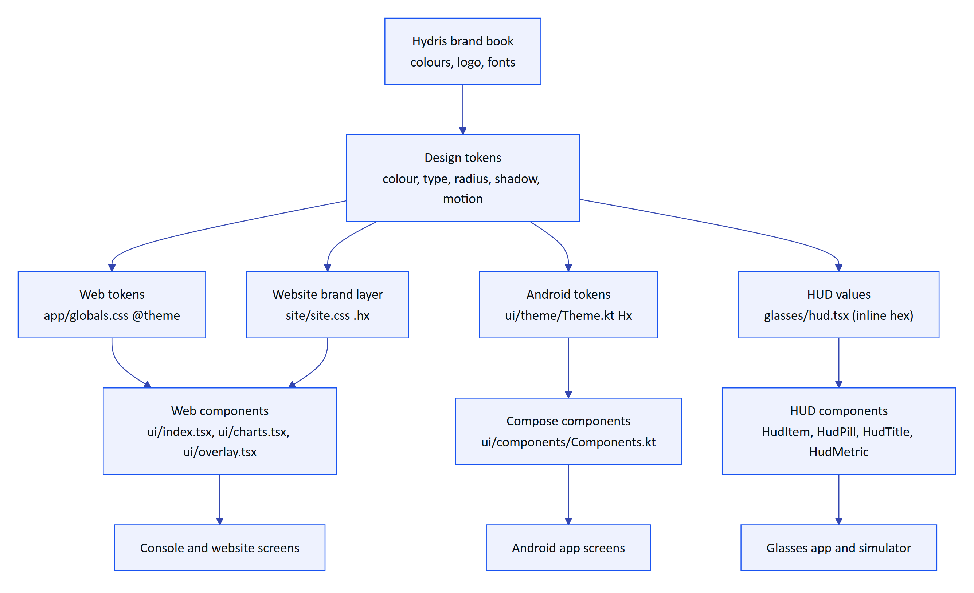
Figure 1. Design system layers, from brand book to screens
Table 1. Where the design system lives in the code
Layer | Web console and website | Glasses HUD and phone mode | Android app | Status
Colour, radius, shadow, motion tokens | apps/web/src/app/globals.css (@theme, :root, :root[data-theme='light']) | Inherits globals.css; severity tints hard-coded in apps/web/src/glasses/hud.tsx and GlassesApp.tsx | apps/android/app/src/main/java/ai/hydris/field/ui/theme/Theme.kt (object Hx) | Partial (three sources, some drift)
Website brand overrides | apps/web/src/site/site.css (.hx scope) | Not used | Not used | Built
Typography roles | .t-display to .t-kpi-sm in globals.css; Outfit via next/font in app/layout.tsx | Tailwind pixel sizes in hud.tsx | Material 3 Typography in Theme.kt | Built
Components | apps/web/src/ui/index.tsx, ui/charts.tsx, ui/overlay.tsx, ui/theme.tsx | hud.tsx primitives plus screens in GlassesApp.tsx | ui/components/Components.kt | Built
Icons | lucide-react 1.57.0 | lucide-react | material-icons-extended (Outlined set) | Built
Theme switching | ui/theme.tsx, ui/theme-script.ts | Forced dark | Dark only | Partial
Shared token package | None | None | None | Planned

RISK
Tokens are defined three times and the HUD uses inline hex values. The values were aligned by hand, and several have drifted (see the severity mapping table). Until a single token source generates all three platforms (Planned, see the future chapter), every colour change must be made in all three files in the same pull request.

3 Brand and colour system

3.1 Brand palette
The brand palette comes from the Hydris AI brand book and is quoted in the header comments of globals.css and site.css. Core Blue is the dominant brand colour on the website; Signal Blue is the action colour in product surfaces. Deep Intelligence Blue (navy) is used for pressed states and deep brand panels.
Table 2. Brand palette
Name | Hex | Role | Where defined
Hydris Core Blue | #1746E4 | Brand fills, hover on primary, chart series 1, website accent | --color-brand (globals.css), --hx-blue (site.css), Hx.Core
Deep Intelligence Blue | #0C1E85 | Pressed primary, deep brand panels, logo navy | --color-brand-deep, --hx-deep
Signal Blue | #1954F1 | Primary buttons, focus fills, selected state, links on paper | --color-signal, --color-lime, Hx.Signal
Signal tint (accent text) | #6F93FF | Accent text and focus ring on dark backgrounds | --color-accent, Hx.SignalText
Deep Midnight | #081116 | App background (dark) | --color-bg, Hx.Midnight
Graphite Black | #222222 | Print and brand graphite | --color-graphite
Pure White | #FFFFFF | Primary text on dark, ink on blue | --color-text
Alert Orange | #FF2800 | Critical severity only | --color-critical, --color-orange, Hx.Alert
Active Green | #00FE21 | OK and live: dots and text only, never large fills | --color-ok, Hx.Ok
Hydris Insight Purple | #8A60F0 | AI, information, secondary data series, synthetic data | --color-purple, --color-cobalt, Hx.Insight

NOTE
The token names lime, lime-2, lime-3 and cobalt are historical. In the code today lime means the brand blue role with white ink, and cobalt means Insight Purple (globals.css header comment). New code should use signal, brand, brand-deep and purple. Renaming the legacy roles is part of the token pipeline work.

3.2 Web neutral and surface tokens (dark and light)
The console defines every semantic token for both themes. The dark values live in @theme; the light values in :root[data-theme='light']. Components refer only to the semantic names, so a theme switch needs no JavaScript.
Table 3. Web surface and text tokens (apps/web/src/app/globals.css)
Token | Dark | Light | Semantic role
--color-bg | #081116 | #F6F8FC | Page background
--color-bg-2 | #0C161C | #EEF2F8 | Inset areas, input wells
--color-surface | #121A20 | #FFFFFF | Cards, menus, dialogs
--color-surface-2 | #1A2229 | #F2F5FA | Secondary buttons, chips, hover
--color-surface-3 | #252E35 | #E5EAF2 | Pressed, disabled primary, progress track
--color-line | white 7.5 % | slate 8.5 % | Hairline borders
--color-line-2 | white 14 % | slate 15 % | Strong borders, inputs
--color-text | #FFFFFF | #1B2129 | Primary text
--color-text-2 | #C5CCD2 | #46505B | Secondary text
--color-muted | #8D979F | #66717D | Labels, meta, captions
--color-paper | #EEF1F4 | #FFFFFF | KPI paper cards (light island on dark page)
--color-ink / --color-ink-2 | #081116 / #4C5862 | #1B2129 / #545F6B | Text on paper
--color-accent | #6F93FF | #1746E4 | Accent text, focus ring
--color-scrim | midnight 72 % | slate 38 % | Modal backdrop
--color-field | #0C161C | #FFFFFF | Input background
--color-placeholder | #67727B | #8A949F | Input placeholder
--color-chart-grid | white 7 % | slate 7 % | Chart gridlines

3.3 Android tokens
The Android app maps the same palette into a Material 3 dark colour scheme (Theme.kt). primary is Signal Blue, secondary is Insight Purple, tertiary is a softer green (OkSoft), error is Alert Orange.
Table 4. Android Hx tokens (apps/android/.../ui/theme/Theme.kt)
Token | Hex | Material role | Use
Hx.Midnight | #081116 | background, surfaceContainerLow | Screen background
Hx.Surface | #0E1A21 | surface, surfaceContainer | Cards, navigation bar
Hx.Surface2 | #13222B | surfaceVariant, surfaceContainerHigh | Raised containers
Hx.Line | white 12 % | outline | Card borders, progress track
Hx.Signal | #1954F1 | primary | Primary buttons, progress, spinner
Hx.Core | #1746E4 | primaryContainer | Pressed and selected
Hx.SignalText | #6F93FF | (direct) | Accent text, selected tab
Hx.Alert | #FF2800 | error | Critical severity
Hx.High | #F26414 | (direct) | High severity, stale data, error notes
Hx.Medium | #F5B83D | (direct) | Medium severity, delayed data
Hx.Ok | #00FE21 | (direct) | Active Green (reserved)
Hx.OkSoft | #34D27A | tertiary | Live data, typical-range band
Hx.Insight | #8A60F0 | secondary | AI, synthetic chip
Hx.Text / Hx.Text2 / Hx.Muted | #F2F5F7 / #B7C2CA / #7D8B95 | onBackground, onSurfaceVariant | Text hierarchy

3.4 HUD colour values
The HUD inherits globals.css, so lime (focus border, selected pill) is Signal Blue #1954F1. Severity tints on the HUD are lighter than the console's, because they must read as thin strokes and text on an additive display. They are currently inline hex values in hud.tsx and GlassesApp.tsx.
Table 5. HUD colour values (apps/web/src/glasses/hud.tsx, GlassesApp.tsx)
Use | Border | Text | Notes
Critical | #FF5A4E | #FF8A80 | HudPill tone="critical", AlertInterrupt border
High | #F26414 | #FF9A5C | Matches Android Hx.High border
Medium | #F5B83D | #F7C96A | Step cautions, safety notices icon
OK | #4ED98E | #7FE6AE | Softer than Active Green to avoid glare
Neutral line | white 25 % | white 80 % | Default pill
Focus / selected | lime (#1954F1) | #141714 on fill | See the contrast findings below
Critical banner background | n/a | n/a | #2A0D0B (critical), #2A1608 (high and offline strip)

3.5 Severity and status colour mapping
Severity colours are semantic and are never reused as decoration (globals.css header). The table shows how each surface renders each severity today, which is where the drift is easiest to see.
Table 6. Severity colour mapping by surface
Severity | Web console fill / text (dark) | Web light text | Website .hx | Android Hx.severity() | HUD border / text
Critical | #FF2800 / #FF7A5C | #C41F00 | #FF2800 | #FF2800 | #FF5A4E / #FF8A80
High | #FF9F1C / #FFB547 | #A35200 | #FF5A1F | #F26414 | #F26414 / #FF9A5C
Medium | #F5C542 / #F7D36E | #7F6000 | (inherits) | #F5B83D | #F5B83D / #F7C96A
Low | #8FB0FF / #B3C9FF | #1746E4 | (inherits) | #6F93FF | neutral line
OK / live | #00FE21 / #00FE21 | #0B7A1F | #00FE21 | #34D27A (live), #00FE21 | #4ED98E / #7FE6AE

DECISION
The canonical High colour is #F26414 (the brand-adjacent orange already used on Android and the HUD). The console's amber #FF9F1C and the website's #FF5A1F will move to it, with a lighter text tint for small text on dark. Critical stays Alert Orange #FF2800 everywhere, with surface-specific text tints for legibility. Status: Planned (token alignment).

The same colours drive object states through StateChip (ui/index.tsx). The mapping rule: red family for "needs attention now", amber for "seen, not finished", purple for "someone is working on it", green for "done or healthy", outline for "neutral or historical".
Table 7. State to tone mapping used by StateChip (apps/web/src/ui/index.tsx)
Tone | States
Critical | active (alarm), down, revoked, urgent
Medium | acknowledged, paused, on_hold, degraded, disconnected
Cobalt (Insight Purple) | investigating, in_progress, assigned, maintenance
OK | resolved, approved, completed, operational, connected
High | rejected, suspended
Brand blue (lime) | submitted
Outline | closed, scheduled, cancelled, open, standby, draft, archived and other neutral states

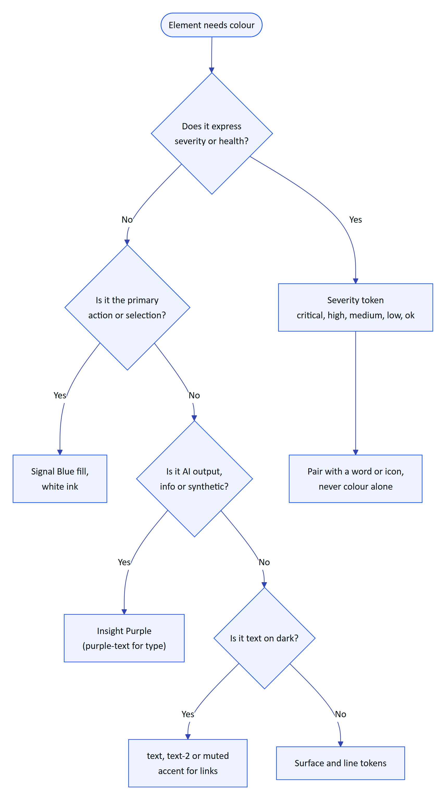
Figure 2. Choosing a colour for a value or element

3.6 Contrast audit
Contrast ratios below were computed with the WCAG 2.x relative luminance formula from the hex values in the code (script run during authoring; alpha tints were not composited and are excluded). The target for all product text is WCAG 2.2 AA: 4.5:1 for normal text and 3:1 for large text (24 px regular or 18.66 px bold and above) and for non-text UI components.
Table 8. Contrast ratios for key colour pairs (computed from code values)
Foreground | Background | Ratio | Result | Where used
White #FFFFFF | Midnight #081116 | 19.05:1 | AAA | Primary text, console and HUD
text-2 #C5CCD2 | surface #121A20 | 10.84:1 | AAA | Secondary text in cards
muted #8D979F | surface #121A20 | 5.91:1 | AA | Labels, meta
muted #8D979F | bg #081116 | 6.41:1 | AA | Captions on page
Signal #1954F1 | Midnight #081116 | 3.25:1 | Large text only | Why accent text uses #6F93FF
Accent #6F93FF | Midnight #081116 | 6.62:1 | AA | Links, selected tab, focus ring
White | Signal #1954F1 | 5.87:1 | AA | Primary button label
White | Core Blue #1746E4 | 6.92:1 | AA | Hover primary, brand panel
White | Deep Blue #0C1E85 | 13.64:1 | AAA | Pressed primary
White | Danger solid #E02400 | 4.75:1 | AA | btn-danger-solid
critical-text #FF7A5C | surface #121A20 | 6.86:1 | AA | Critical chip text
high-text #FFB547 | surface | 10.01:1 | AAA | High chip text
ok-text #00FE21 | surface | 12.73:1 | AAA | OK chip text
purple-text #B69CFF | surface | 7.69:1 | AAA | Insight and synthetic chips
Ink #081116 | paper #EEF1F4 | 16.81:1 | AAA | KPI paper cards
Light text #1B2129 | White | 16.20:1 | AAA | Light theme body
Light muted #66717D | bg #F6F8FC | 4.68:1 | AA | Light theme labels
Light critical #C41F00 | White | 5.93:1 | AA | Light theme critical text
Light high #A35200 | White | 5.58:1 | AA | Light theme high text
Light ok #0B7A1F | White | 5.50:1 | AA | Light theme OK text
Android Text2 #B7C2CA | Surface #0E1A21 | 9.75:1 | AAA | Secondary text
Android Muted #7D8B95 | Surface #0E1A21 | 5.05:1 | AA | Meta lines
Android Insight #8A60F0 | Surface #0E1A21 | 4.22:1 | Fails AA (normal) | Synthetic chip text
White | Android Alert #FF2800 | 3.78:1 | Fails AA (normal) | Filled critical chip, 12 sp
White | Android High #F26414 | 3.18:1 | Fails AA (normal) | Filled high chip, 12 sp
HUD critical #FF8A80 | Black | 9.20:1 | AAA | HUD critical text
HUD white 55 % (about #8C8C8C) | Black | 6.25:1 | AA | HUD meta lines
HUD ink #141714 | Signal #1954F1 | 3.08:1 | Large text only | Selected pill, View button, digit entry

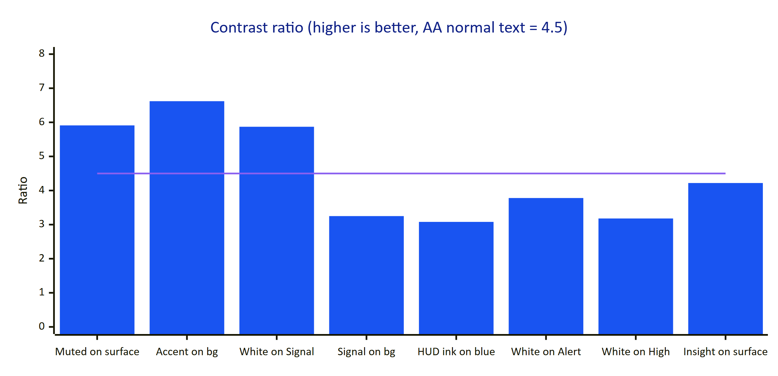
Figure 3. Contrast of selected text pairs against the 4.5:1 AA threshold
WARNING
Three contrast failures exist in shipped code. (1) HUD selected pill and View button: #141714 ink on Signal Blue is 3.08:1. The ink colour is a leftover from when the lime role was a light lime green. Fix: white ink on the blue fill (5.87:1) in HudPill tone="lime", AlertInterrupt and the digit-entry cell in GlassesApp.tsx. (2) Android filled severity chips: white on #FF2800 (3.78:1) and on #F26414 (3.18:1) at 12 sp. Fix: use the tinted chip style (coloured text on a 14 % fill) or dark ink on the fill. (3) Android synthetic chip: Insight #8A60F0 text on Surface is 4.22:1. Fix: add an Hx.InsightText tint equivalent to the web #B69CFF. Status: Planned fixes, tracked in the QA checklist.

4 Typography

4.1 Typefaces
Table 9. Typefaces by surface
Surface | Typeface in code | Source | Status
Console, website, glasses web app, simulator | Outfit (300, 400, 500, 600) | next/font/google in apps/web/src/app/layout.tsx, exposed as --font-outfit | Built
Monospace (IDs, codes) | System UI monospace stack | --font-mono in globals.css | Built
Android app | Platform default (Roboto on most devices) | Material 3 Typography without a custom FontFamily | Built
Word and PDF product documents | Arial and Calibri | docs/product/tools/build.js theme | Built
Brand typefaces Unison Pro (display) and Eloquia Text (body) | Not in any product surface | Brand book | Planned (licensing for web and app embedding)

DECISION
Product UI keeps Outfit and the platform font until web and app embedding licences for Unison Pro and Eloquia Text are confirmed. When they are, Unison Pro is limited to display roles (t-display, t-hero, website headings) and Eloquia Text replaces Outfit for body roles. Numerals in KPIs keep tabular figures (.num), whichever face is used.

All numeric values use tabular, lining figures (.num in globals.css: font-variant-numeric: tabular-nums lining-nums) so live values do not jitter as digits change. HUD metrics and digit-entry cells apply .num too.

4.2 Web type scale
Table 10. Web typography roles (apps/web/src/app/globals.css)
Role class | Size | Line height | Tracking | Weight | Use
t-display | clamp 44 to 92 px | 1.02 | -0.04 em | 600 | Website hero
t-hero | clamp 36 to 64 px | 1.04 | -0.035 em | 600 | Website section heroes
t-page | clamp 30 to 44 px | 1.06 | -0.03 em | 600 | Console page titles
t-section | 21 px | 1.25 | -0.02 em | 600 | Card groups, dialog titles
t-card | 16.5 px | 1.3 | -0.012 em | 600 | Card titles
body (.input, table) | 14 to 14.5 px | 1.5 | normal | 400 | Body text, tables, inputs
t-label | 13 px | 1.35 | 0.005 em | 400 | Field labels, KPI labels
t-eyebrow | 11.5 px | 1.4 | 0.16 em, uppercase | 500 | Section eyebrows
t-kpi | clamp 38 to 54 px | 0.95 | -0.045 em | 300 | KPI numerals
t-kpi-sm | 28 px | 1.05 | -0.035 em | 300 | Secondary KPI numerals
Table header | 11.5 px | n/a | 0.08 em, uppercase | 500 | .table th

4.3 Android type scale
Table 11. Android typography (apps/android/.../ui/theme/Theme.kt)
Material role | Size | Weight | Tracking | Use
displaySmall | 34 sp / 38 sp | SemiBold | -0.8 sp | Large greetings
headlineSmall | 24 sp | SemiBold | -0.4 sp | Screen titles ("Audit scan", "Glasses")
titleLarge | 20 sp | SemiBold | -0.2 sp | Section titles
titleMedium | 16 sp | Medium | 0 | List item titles, option rows
bodyLarge | 16 sp / 22 sp | Regular | 0 | Primary body
bodyMedium | 14 sp / 20 sp | Regular | 0 | Secondary body, KPI labels
bodySmall | 12.5 sp / 17 sp | Regular | 0 | Meta lines
labelSmall | 11 sp | Medium | 1.4 sp | Eyebrows (uppercase)
KPI value (inline) | 34 sp | SemiBold | -1 sp | KpiTile value
Alarm reading (inline) | 36 sp | SemiBold | 0 | Alarm detail reading

Sizes are in sp, so the app follows the operator's system font-size setting. Built.

4.4 HUD type scale
The HUD is designed on a 600 by 600 canvas. All sizes below are canvas units, scaled to the display.
Table 12. HUD typography (apps/web/src/glasses/hud.tsx, GlassesApp.tsx)
Role | Size | Weight | Use
HudTitle | 38 | Regular, -0.03 em | Screen title
HudMetric value | 52 | Light, tabular | Key reading
Digit entry cell | 56 | Light, tabular | Inspection numeric input
Alert interrupt title | 34 | Regular | Full-screen alarm
HudItem row | 23 | Regular | List rows, actions
Body and instructions | 19 to 22 | Regular | Step instructions, SOP text
Status bar | 18 | Regular | Connection, queue, operator
HudPill | 18 | Medium | Status pills
Eyebrow | 17 | Uppercase, 0.14 em | Section and step labels
Meta line | 17 | Regular, white 55 % | Secondary row text
Hint bar | 16 | Regular, white 45 % | Control hints

TIP
The HUD comment sets the floor at 20 px for content. Meta lines, eyebrows and hints at 16 to 18 are allowed because they are secondary and never carry the only copy of a safety-relevant value. A UI profile can raise everything with layout.textScale (0.9, 1, 1.15, 1.3; clamped to 0.85 to 1.4) in packages/domain/src/uiprofile.ts; the glasses app applies it with CSS zoom in GlassesApp.tsx. Built.

5 Spacing, radius and elevation

5.1 Spacing
Web layouts use the Tailwind 4 spacing scale (4 px base) without custom spacing tokens. The recurring values are documented here so new screens stay on the rhythm.
Table 13. Spacing rhythm in use
Context | Web console | Android | HUD
Page gutter | 16 px mobile, 32 px from md (px-4 md:px-8) | 16 dp (padding(horizontal = 16.dp)) | 32 units HUD, 24 units phone mode (px-8 / px-6)
Card padding | 24 px (.card), 18 px tight, 20 to 24 px KPI | 16 dp default, 14 dp list cards | 16 to 24 units
Gap between cards | 12 to 16 px | 12 dp (Row2, spacedBy(12.dp)) | 12 units
Section top spacing | 32 px (pt-8) | 20 dp (SectionTitle) | 20 units (HudTitle margin)
Max content width | 1440 px (max-w-[1440px]) | Full width | 600 units (HUD) / 540 units (phone)

5.2 Radius
Table 14. Radius tokens
Token | Value | Use
--radius-xs | 6 px | Small tags, kbd
--radius-sm | 10 px | Skeletons
--radius-md | 14 px | Inputs, selects
--radius-lg | 18 px | Inset cards, menus
--radius-xl | 24 px | Cards, panels, empty states
--radius-2xl | 32 px | Centered dialogs
Pill | 9999 px | Buttons, chips, capsules, icon buttons
Android CardShape | 22 dp | HCard
Android chip / progress | 50 % | Chip, ProgressBar
HUD row | 26 units | HudItem
HUD alert | 34 units | AlertInterrupt

5.3 Elevation
Elevation on dark surfaces comes from a top-edge sheen and graded surface colours more than from shadows.
Table 15. Elevation tokens (globals.css)
Token | Dark | Light | Use
--sheen | inset 1 px white 4.5 % | soft 1 to 2 px shadow | Every card and capsule
--shadow-1 | 1 px plus 8 px blur, black 20 to 30 % | slate 5 % | Resting raised elements
--shadow-2 | 6 px plus 28 px, black 30 to 35 % | slate 6 to 9 % | Hover lift, glass panels
--shadow-3 | 12 px plus 72 px, black 35 to 55 % | slate 8 to 16 % | Menus, dialogs, mobile tab bar
Brand panel glow | 18 px 48 px Core Blue 22 % | 18 % | .card-lime focal panel

Android cards are flat (tonalElevation = 0 on the navigation bar, no shadow on HCard), separated by a 1 dp Hx.Line border. The HUD uses no shadows at all, since shadows are invisible on an additive display.

6 Iconography
Table 16. Icon systems
Surface | Library | Style | Default sizes | Status
Console and website | lucide-react 1.57.0 | 1.5 to 2 px stroke, rounded | 19 px navigation, 16 to 18 px buttons, 14 px inline | Built
Glasses HUD and phone mode | lucide-react | Same | 22 to 28 units | Built
Android | androidx.compose.material:material-icons-extended | Outlined set (Icons.Outlined.*, Icons.AutoMirrored.Outlined.*) | 18 to 24 dp | Built

The two libraries are visually close (outlined, geometric), which keeps the surfaces consistent without sharing assets. Use the same concept for the same meaning:
Table 17. Icon concept mapping across surfaces
Concept | Lucide (web, HUD) | Material Outlined (Android)
Home / overview | LayoutGrid, Glasses (HUD home tab) | Dashboard
Alarms | Siren (console nav), AlertTriangle (HUD) | Warning
Inspections | ClipboardCheck | FactCheck
Maintenance | Wrench | Build
Audit scan | ScanLine | DocumentScanner
Voice / Hydris AI | Mic, Sparkles | AutoAwesome, Mic, MicOff
Glasses / devices | Glasses | Visibility
Back | ChevronLeft | AutoMirrored.Outlined.ArrowBack
Camera | n/a | PhotoCamera
Safety notice | ShieldAlert | n/a
Not permitted | Ban | n/a

Rules: icons never stand alone for an action on the HUD or phone (always with a label); icon-only buttons on the web carry an aria-label and a Tooltip (IconButton in ui/index.tsx); decorative icons are aria-hidden.

7 Component library

7.1 Component inventory
Table 18. Component inventory
Component | Purpose | Surfaces | States | Status
Button, ButtonLink | Actions: primary, secondary, ghost, light, cobalt, danger, danger-solid | Web | default, hover, active, focus, disabled, busy (aria-busy) | Built
IconButton | Circular icon actions with label and badge | Web | default, light, lime, ghost, outline, on-paper, danger; sm, md, lg | Built
Material Button, OutlinedButton | Primary and secondary actions, 52 to 54 dp tall | Android | enabled, disabled (busy) | Built
Card | Section container (dark, paper, lime focal) | Web | default, tight, hover lift | Built
HCard | Card with optional click and accent border | Android | default, clickable, accent | Built
KpiCard | KPI island: label, value plus unit, sub line, open link | Web | paper, dark, lime; critical, high, ok accent | Built
KpiTile | KPI tile: label, 34 sp value, sub line, icon | Android | accent colour, clickable | Built
HudMetric | Large reading with unit and label | HUD | tone colour | Built
Chip, SeverityChip, StateChip | Status and category labels | Web | 10 tones including synthetic | Built
Chip (Compose) | Status label | Android | tinted, filled | Partial (filled contrast)
HudPill | Status pill on HUD | HUD | line, lime, critical, high, ok, medium | Partial (lime contrast)
FreshnessBadge | Live, delayed, stale, no data with time | Web | 4 freshness states, pulsing live dot | Built
SyntheticBadge | Marks simulator data | Web, HUD text, Android chip | n/a | Built
Capsule | Segmented control and filters | Web | selected, hover, counts, lime variant | Built
Input, PasswordInput, Select, Textarea, Field | Forms with label, hint, error | Web | hover, focus, invalid, disabled | Built
Switch | Boolean settings | Web | on, off, disabled | Built
DataTable | Sortable, clickable tables | Web | hover, focus, selected, dense, empty | Built
Timeline | Event history | Web | lime, critical, ok, muted, cobalt | Built
KeyValues | Definition grid | Web | 1 to 3 columns | Built
Progress | Progress bar with ARIA | Web | lime, ok, critical | Built
ProgressBar | 6 dp progress bar | Android | colour | Built
Dialog, ConfirmDialog | Modal, side panel, bottom sheet; confirmation with optional required note | Web | open, destructive, note required | Built
Toasts (ToastProvider, useToast) | Transient confirmations with timer | Web | info, error | Built
EmptyState, ErrorState, LoadingBlock, Skeleton, QueryView | Data states | Web | empty, not found, forbidden, error with retry, loading | Built
Loading, ErrorNote | Data states | Android | spinner, error note | Built
HudItem | Focusable HUD row | HUD | active (focus), disabled, tone | Built
HudTitle | Screen title with eyebrow | HUD | n/a | Built
PhoneTabBar | Bottom tab bar in phone mode | Glasses phone mode | active, back, badge | Built
HintBar | Control hints aligned to handedness | HUD | left, right | Built
AlertInterrupt | Full-screen critical or high alarm | HUD | critical, high, synthetic | Partial (button contrast)
GuidedCapture | Live A4 framing with guidance and auto-capture | Glasses, web | 8 guidance codes, ready progress | Built
Web charts (ui/charts.tsx) | Sparkline, Sparkbars, BarStrip, Gauge, RadialGauge, Donut, StackedBar, BarList, Heatmap, BulletBar, RangeBar, Delta, MiniTrend, Funnel, StatusStrip, TrendChart | Web | empty state, screen-reader table | Built
Android charts | Sparkline, LineChart, Bars, Donut (Canvas) | Android | fewer than 2 points draws nothing | Partial (no accessible description)
ThemeToggle | System, light, dark | Web | checked, compact | Built
Haptic feedback | Confirm critical actions by vibration | Android, glasses | n/a | Planned

7.2 Cards
Web Card (ui/index.tsx, .card in globals.css): surface background, 1 px line border, 24 px radius, 24 px padding, sheen. Three tones: default dark; paper (light island on a dark page, used for KPIs so numbers pop); lime, the focal brand panel, a radial gradient of Core Blue with white type. Use at most one focal panel per view. Interactive cards opt into .lift (2 px rise on hover, settle on press).
Android HCard (Components.kt): Hx.Surface, 22 dp radius, 1 dp Hx.Line border, 16 dp padding. Passing accent tints the border at 55 % alpha; the home screen uses this for critical alarm cards and the alarm detail uses a Signal accent for the recommended action card.
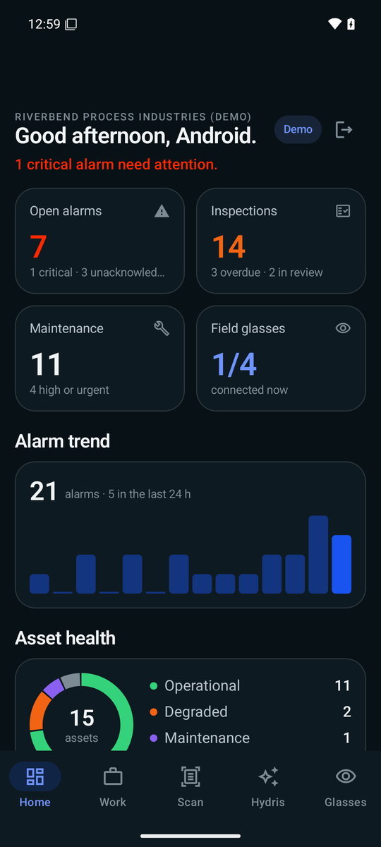
Figure 4. Android home: KPI tiles, accent-bordered alarm cards and sparkline rows

7.3 KPI tiles
Table 19. KPI tile specification
Property | Web KpiCard | Android KpiTile | HUD HudMetric
Minimum height | 124 px, 148 px from sm | Content height | Content height
Label | 13.5 px, 75 % opacity, top left | bodyMedium, Text2, single line | 17, white 60 %, below value
Value | t-kpi (38 to 54 px, light 300) | 34 sp SemiBold | 52 light
Unit | 15 px, 60 % opacity, baseline aligned | Inline in value or sub | 20, white 60 %
Accent | kpi-accent-critical, -high, -ok; deepened on paper for AA | accent colours the value | tone colours the value
Link | OpenLink arrow, top right | Whole tile clickable | Not interactive
Sub line | 13 px, 70 % opacity | bodySmall, Muted | n/a

Rules: a KPI value is a fact with a unit and a time context ("in the last 24 h"); never show a KPI computed from stale data without saying so; never use the accent colour unless the number itself is the alert.
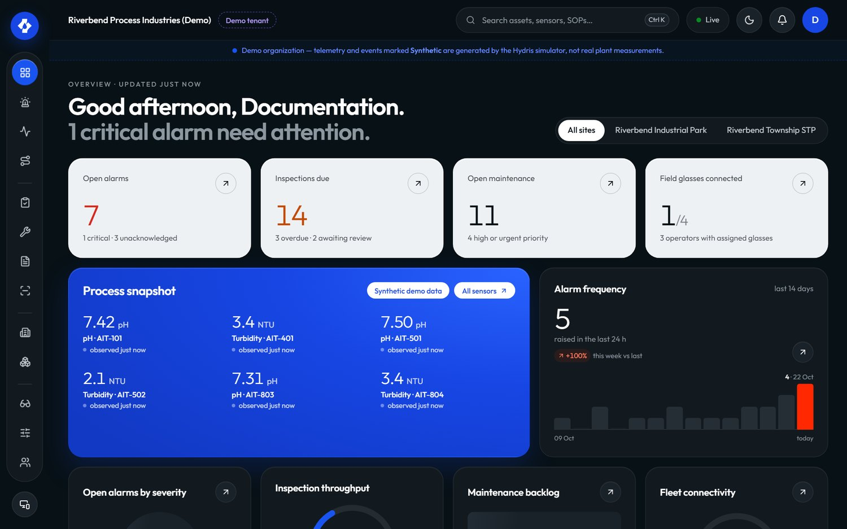
Figure 5. Console overview: paper KPI islands, focal blue panel and live charts

7.4 Chips and badges
Web chips are 28 px tall pills, 12.5 px medium text, with a 1 px tinted border and a 12 to 15 % tinted fill per tone. Clickable chips get a 44 px hit area through an ::after pseudo-element. SeverityChip adds a dot in the severity colour plus the word. chip-synthetic is a dashed purple outline so simulated data is recognisable even in greyscale.
Android Chip is 12 sp medium text with 10 by 4 dp padding on a 14 % tint, or a solid fill when filled = true (alarm severity on the alarm detail screen). The HUD HudPill is 34 units tall with a 2 unit border and 18 unit text; on the HUD, outlines are preferred to fills.

7.5 Buttons
Table 20. Button specification (globals.css)
Variant | Fill | Text | Hover | Use
btn-primary | Signal #1954F1 | White | Core Blue plus blue glow; pressed Deep Blue | One per view: the main record action
btn-secondary | surface-2 | text | surface-3 | Secondary actions
btn-ghost | transparent | text-2 | surface-2 | Tertiary, toolbars
btn-light | White | ink | paper | On the blue focal panel
btn-cobalt | Core Blue | White | Deep Blue | Brand emphasis on the website
btn-danger | transparent, orange border | critical-text | 12 % orange fill | Reversible destructive actions
btn-danger-solid | #E02400 | White | #C41F00 | Irreversible destructive confirmation

Sizes: btn-sm 36 px (with an invisible 44 px hit area), default 44 px, btn-lg 52 px. All buttons scale to 0.97 on press, show 50 % opacity when disabled (the disabled primary turns into a neutral surface so it reads as "not yet" rather than a faded blue), and set aria-busy while an action is in flight. Android primary actions are Material Button at 52 to 54 dp height and full width in task flows (alarm detail, scan review), with OutlinedButton for secondary actions.

7.6 Inputs and forms
Inputs are at least 46 px tall, 14 px radius, 14.5 px text, on --color-field with a line-2 border. Focus shows a Signal Blue border plus a 4 px Signal glow at 22 %; invalid inputs show a critical border and a field-error line prefixed by a small critical dot (so the error is not colour-only). Field always renders a visible label, an optional hint and an error, linked by id. Glove-friendly rules: never rely on small inline controls in the field apps; on Android use full-width text fields (the Ask screen uses a 26 dp radius pill field) and full-width buttons.

7.7 Tables
.table (globals.css) and DataTable (ui/index.tsx): sticky uppercase 11.5 px headers, 13 px row padding (10 px dense), hover wash, a 2 px Signal inset on the first cell of clickable rows, keyboard focus outline, and a 14 % Signal fill for the selected row. Sorting uses aria-sort on the header. Tables belong to the console only; phones and the HUD use lists.
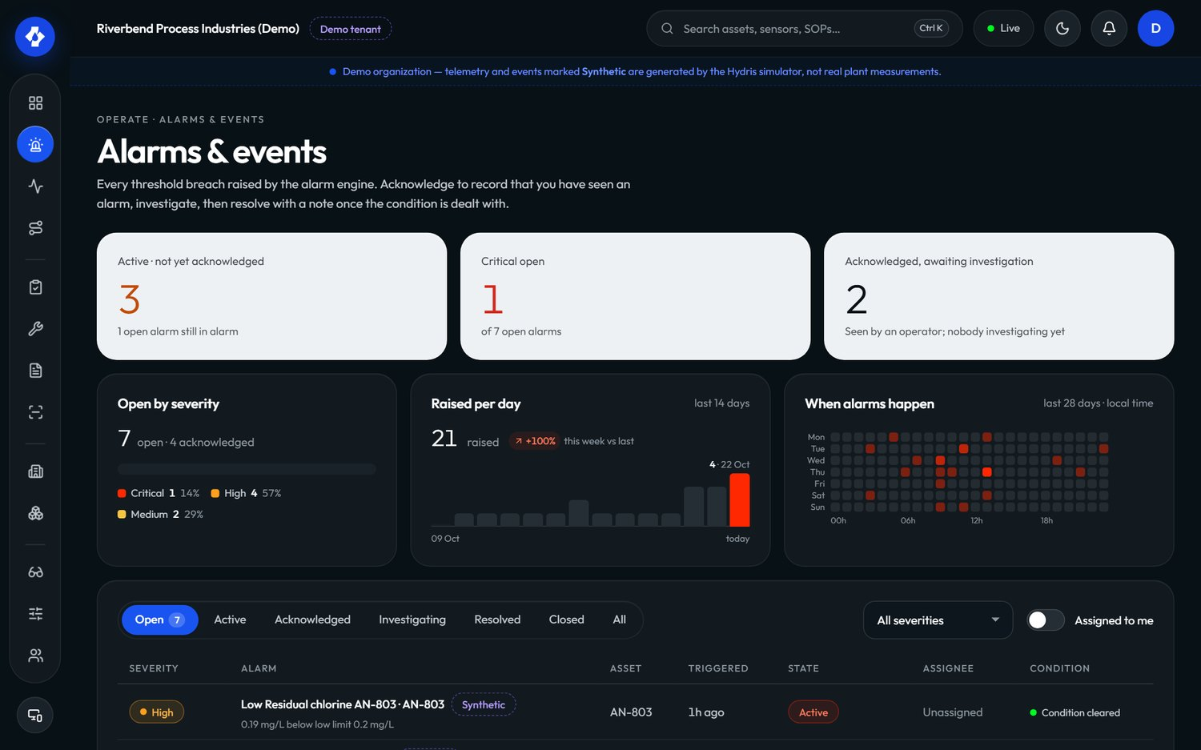
Figure 6. Console alarms list: severity chips, state chips and clickable rows

7.8 Alarm rows
An alarm row shows, in this order: severity (chip or coloured border plus word), title, value with unit, asset tag, state, and time since it was raised. Synthetic alarms add the synthetic marker.
Table 21. Alarm row anatomy by surface
Element | Console table row | Android list card | HUD HudItem
Severity | SeverityChip (dot plus word) | Accent border (critical) plus severity colour | tone colours the text, pill on detail
Title | Primary text | titleMedium | 23 unit row text
Value and unit | Column | Meta line | Detail screen, 24 unit
State | StateChip | Chip on detail | Meta line ("active · 3m ago")
Time | Relative | ago() (just now, 5m ago) | timeAgo
Synthetic | SyntheticBadge | Purple chip | "· synthetic"
Open | Row click | Card click to alarm/{id} | Select to alert screen

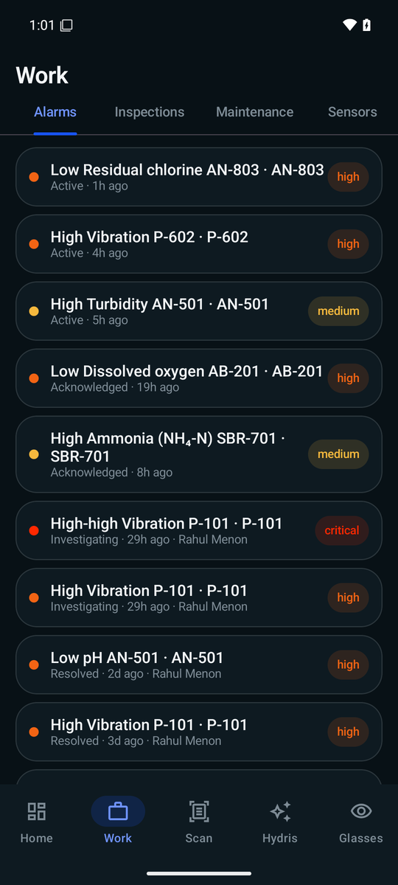
Figure 7. Android work list with alarms grouped by severity
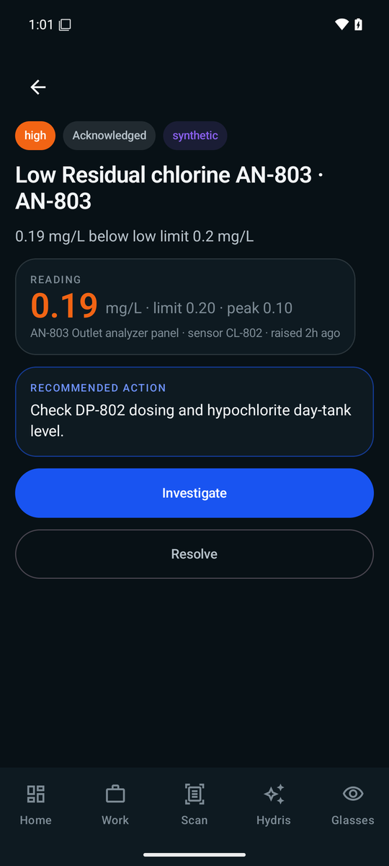
Figure 8. Android alarm detail: reading, limit, recommended action and the next lifecycle action

7.9 Charts
Web charts (apps/web/src/ui/charts.tsx) are hand-built SVG microcharts, plus TrendChart built on Recharts AreaChart. Every chart reads colours from CSS variables, is an accessible image (role="img" with aria-label), can render a screen-reader data table (SrTable), and shows an explicit empty state instead of inventing numbers. Android charts are drawn on Compose Canvas without a chart library (Components.kt; the mobile spec's Vico choice was not adopted).
Table 22. Chart specifications
Chart | Web | Android | Specification
Sparkline | Sparkline: default 40 px tall, stroke --color-lime | Sparkline: 2 dp round stroke, range padded 7.5 % top and bottom | No axes; trend only; always next to the current value
Line / trend | TrendChart (Recharts area, 260 px, thresholds as reference lines, typical band); MiniTrend with band and limits | LineChart: typical range shaded in OkSoft 8 %, 3 gridlines, 28 % gradient fill, end-point dot | Thresholds and typical range always drawn when known
Bars | Sparkbars (peak emphasis), BarStrip, BarList, StackedBar | Bars: 4 dp gaps, 4 dp radius, last bar full colour, others 45 % | Highlight only the bar that matters (latest or peak)
Donut | Donut: 156 px, 14 px ring, centre value, legend with percentages | Donut: 14 dp stroke, 2 degree gaps, starts at 12 o'clock, centre slot | Compositions only; at most 5 segments
Gauges | Gauge, RadialGauge with marks and band | n/a | Single value against a range
Heatmap | Heatmap (week by hour) | n/a | Event density
Progress | Progress, BulletBar (target) | ProgressBar | Fraction of a known total

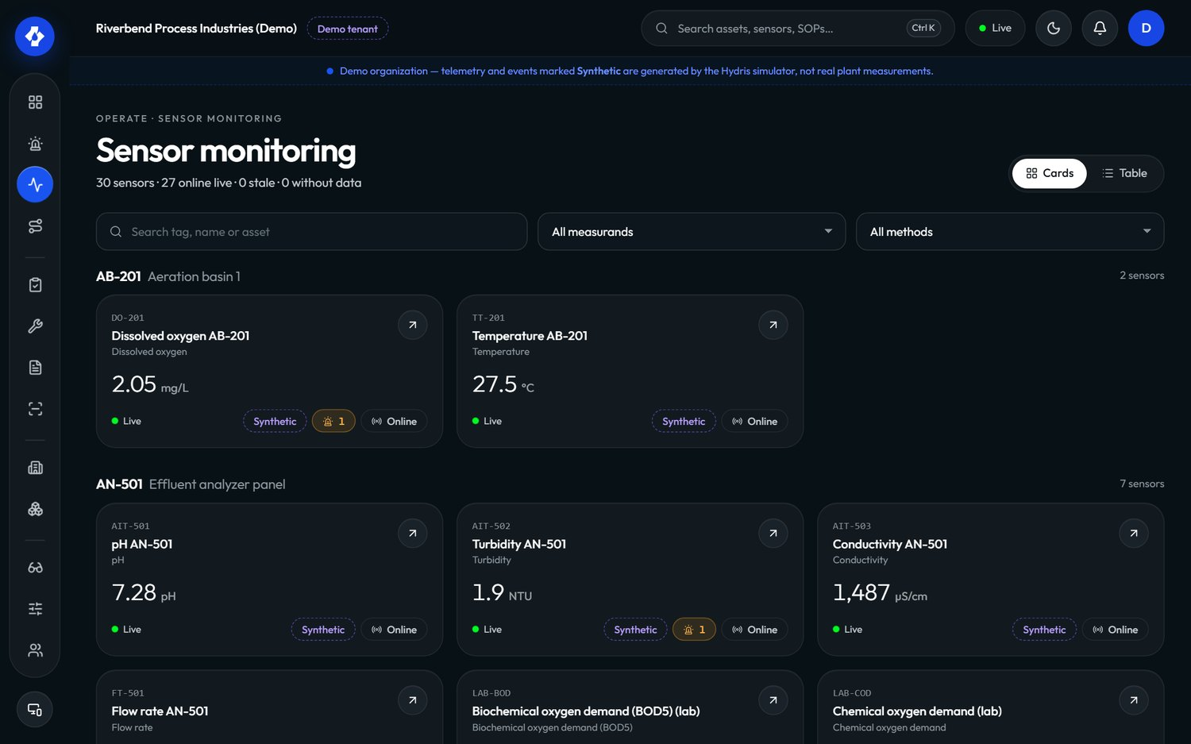
Figure 9. Console telemetry: trend chart with thresholds and freshness

7.10 Empty, loading and error states
Table 23. Data state patterns
State | Web | Android | HUD
Loading | LoadingBlock skeleton rows with shimmer, role="status"; QueryView keeps last good data while refetching | Loading: Signal Blue spinner | "Generating…", "Context will load when the connection returns"
Empty | EmptyState: dashed border, concentric art, title, body, action | Inline text ("No ..."), per screen | Plain 22 unit sentence ("This alert is no longer open.")
Not found | ErrorState turns 404 and invalid ids into "We couldn't find that record" with a back link | n/a | n/a
Forbidden | "You do not have access to this" with admin guidance | Server error text | NotPermitted screen and Blocked notes
Error | Red-tinted role="alert" panel with message and Retry | ErrorNote: High tint panel with message | Banner (role="status") in critical or high tone
Offline | Realtime status in shell | Error notes | Offline strip plus queued counter

8 Data visualisation guidelines
- Show the value, its unit and its time together. A number without freshness is not shown. Use FreshnessBadge (web) or Hx.freshness() (Android: live OkSoft, delayed Medium, stale High, no data Muted).
- Never plot invented data. Missing readings are gaps, not zeros (freshness.ts); charts render their empty state ("No data", "No records").
- Limits and typical ranges are context, not decoration. Draw thresholds as reference lines and typical ranges as a faint band (Android LineChart, web MiniTrend and TrendChart).
- One highlight per chart. Emphasise the latest or peak bar; mute the rest (Sparkbars emphasise, Android Bars 45 % alpha).
- Severity colours only for severity. Series colours come from the brand set (Signal, Core Blue, Insight Purple, text-2) in that order; Alert Orange is reserved for critical.
- Every chart has a text equivalent. Web: aria-label plus optional SrTable. Android: Planned (Modifier.semantics { contentDescription } on chart canvases).
- Tabular figures for every numeric axis, legend and value.
- HUD: no charts beyond a single sparkline. On the glasses, a reading and its state word beat any chart.

9 Layout grids

9.1 Console desktop
The console shell (apps/web/src/console/Shell.tsx) has a fixed 84 px icon rail on the left from the md breakpoint, a sticky blurred header with the search trigger (Ctrl or Cmd K command palette), theme toggle and account menu, an optional demo banner, and a main column capped at 1440 px with 32 px gutters. Below md the rail becomes a floating bottom capsule bar with four primary items (Overview, Alarms, Sensors, Inspections) and More, which opens an "All modules" bottom sheet.
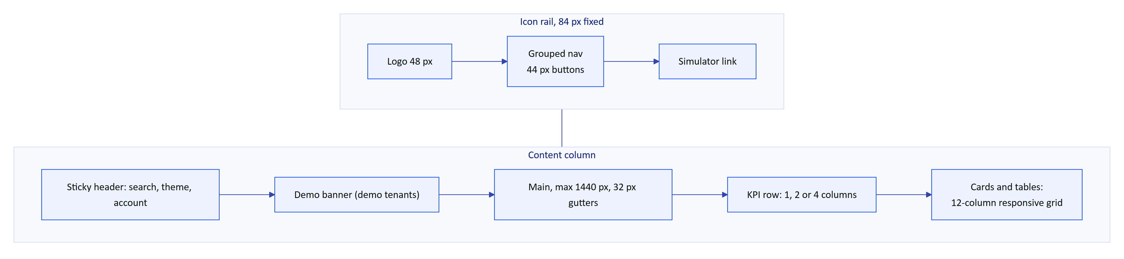
Figure 10. Console desktop layout regions (md breakpoint and wider)
Table 24. Console breakpoints and grid behaviour
Breakpoint (Tailwind) | Navigation | KPI row | Content grid
Below sm (640 px) | Bottom capsule bar plus More sheet | 1 to 2 columns | Single column; dialogs become bottom sheets
sm to md | Bottom capsule bar | 2 columns | Single column; centred dialogs
md (768 px) and up | 84 px rail | 2 columns | Two-column card layouts begin
lg (1024 px) | Rail | 2 to 3 columns | Main plus side column
xl (1280 px) and up | Rail | 4 columns (xl:grid-cols-4) | Full dashboard grid, max 1440 px

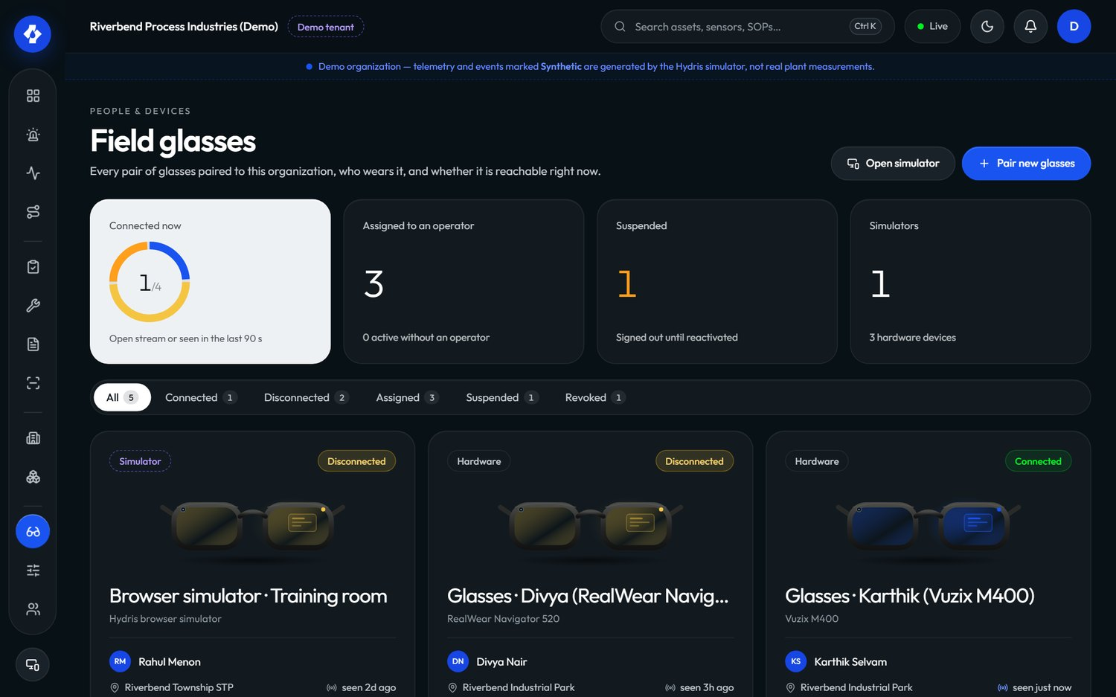
Figure 11. Console devices: table layout inside the 1440 px content column

9.2 Phone (glasses phone mode and Android)
The glasses web app switches to phone mode for portrait phones, the Ray-Ban Meta companion app and any page with ?mode=phone (useViewportLayout in hud.tsx). Phone mode keeps a 540-unit design width (PHONE_DESIGN_WIDTH), scales by window width / 540, and grows to the full device height so screens fill the phone instead of sitting in a letterboxed square. Safe areas are respected with env(safe-area-inset-top) on the status bar and env(safe-area-inset-bottom) on the tab bar.
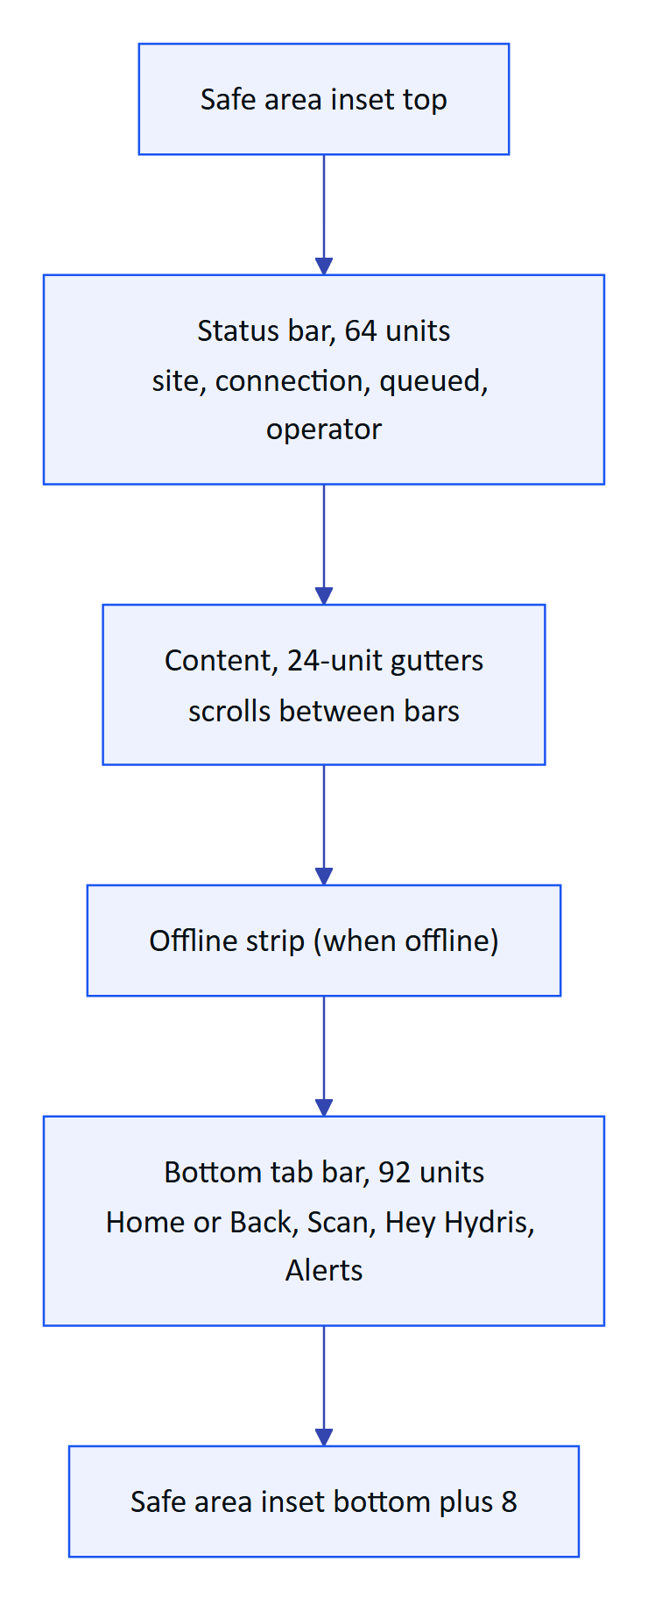
Figure 12. Phone mode layout, 540-unit design width with safe areas
The Android app follows the same structure natively: statusBarsPadding(), 16 dp horizontal padding, a LazyColumn of cards with 12 dp spacing, and a Material NavigationBar with five tabs (Home, Work, Scan, Hydris, Glasses) on Hx.Surface, selected items in SignalText with an 18 % Signal indicator (ui/Root.kt).
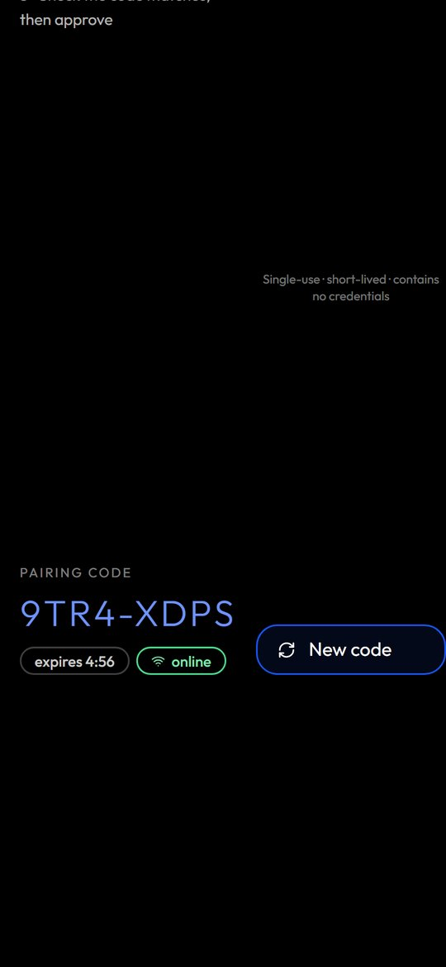
Figure 13. Glasses app in phone mode: pairing screen on a phone

9.3 HUD 600 by 600
The HUD canvas is 600 by 600 units scaled to fit (useFitScale, useViewportLayout). The simulator also offers 640 by 480 and 480 by 480 viewports (apps/web/src/app/simulator/page.tsx) to test other display shapes.
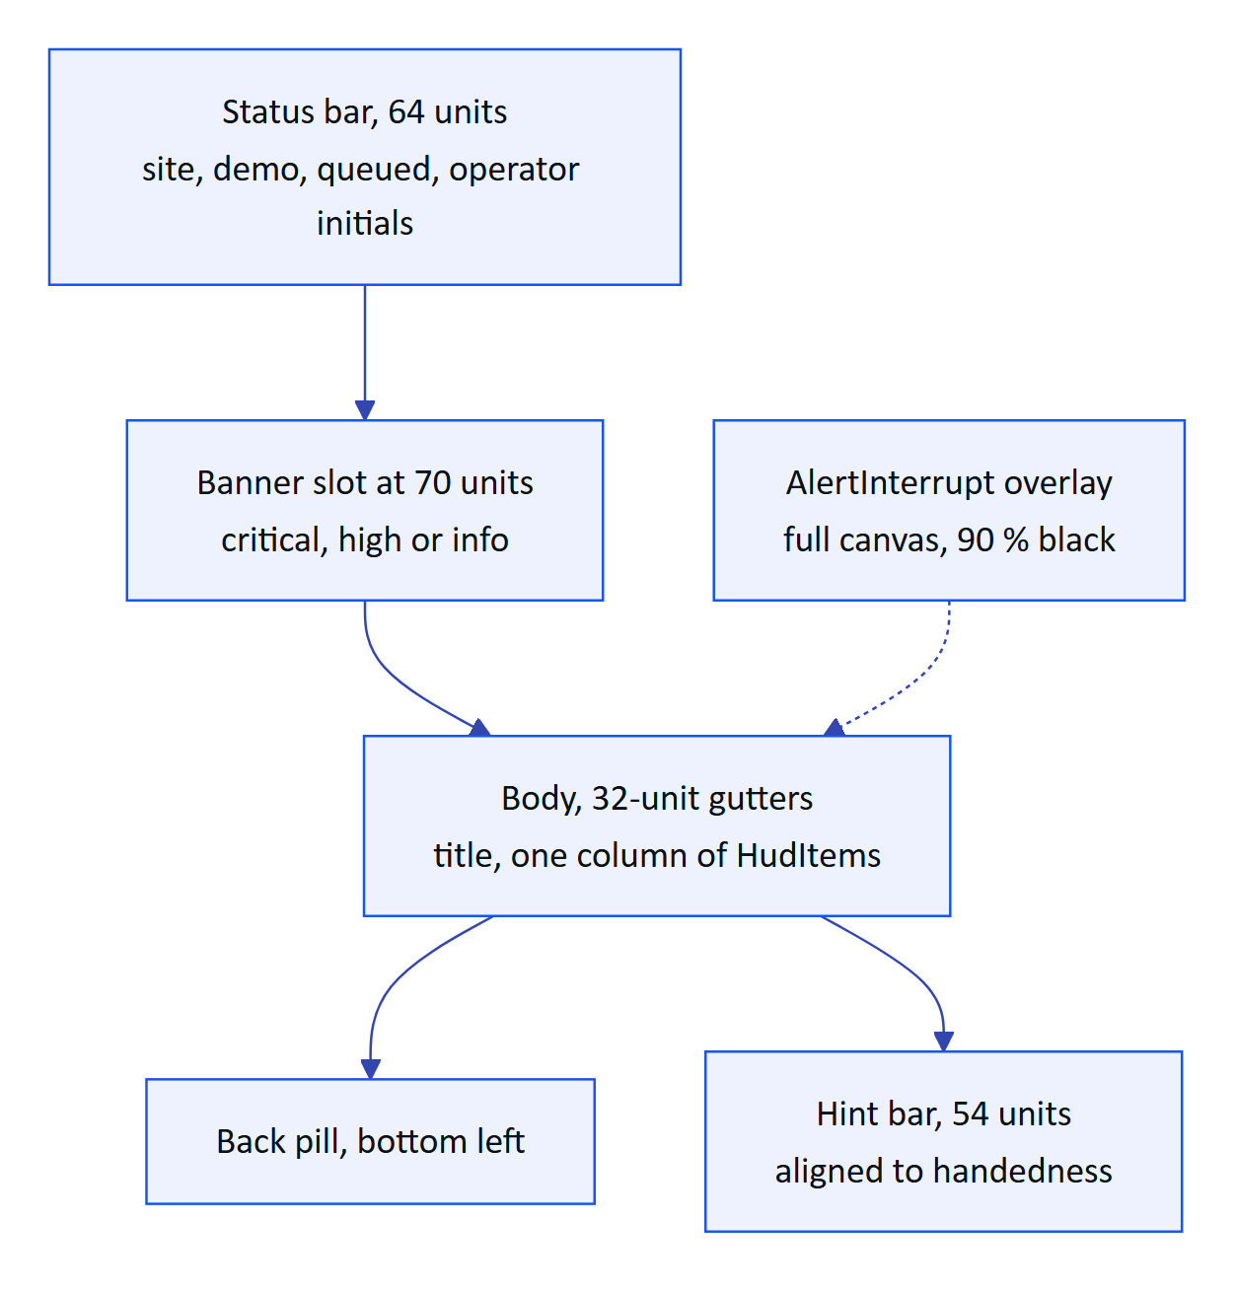
Figure 14. HUD 600 by 600 layout regions
Table 25. HUD layout rules
Rule | Value | Source
Canvas | 600 by 600 units, black (renders transparent) | hud.tsx
Gutters | 32 units (HUD), 24 units (phone) | GlassesApp.tsx
Columns | One | hud.tsx header comment
Focus | One focused HudItem with Signal border and 10 % Signal fill | HudItem
Row height | 14 units vertical padding (comfortable), 9 units (compact) | HudItem, layout.density
Primary actions | One per screen | hud.tsx header comment
Hint bar | Right or left aligned per layout.handedness | HintBar
Text scale | layout.textScale 0.85 to 1.4 | uiprofile.ts

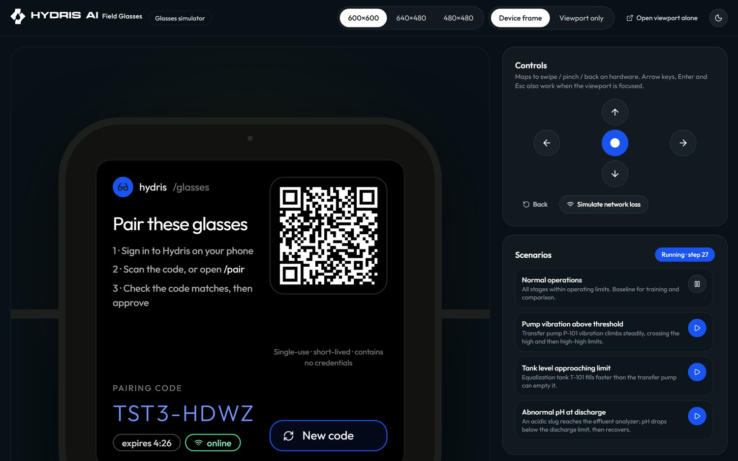
Figure 15. Glasses simulator: HUD viewport, device frame, input pad and event console

9.4 UI profiles shape the layout
Administrators control what the glasses show through versioned UI profiles (packages/domain/src/uiprofile.ts): 12 screens (Home and Device and session can never be disabled), 4 home widgets, 8 actions, a measurement allow-list and per-asset-type order, plus layout density, text scale and handedness. The most specific published assignment wins entirely: device, then user, then role, then organisation, then the built-in default. Designers must design every glasses screen for both densities, all four text scales and both hands.

10 Navigation patterns

10.1 Console information architecture
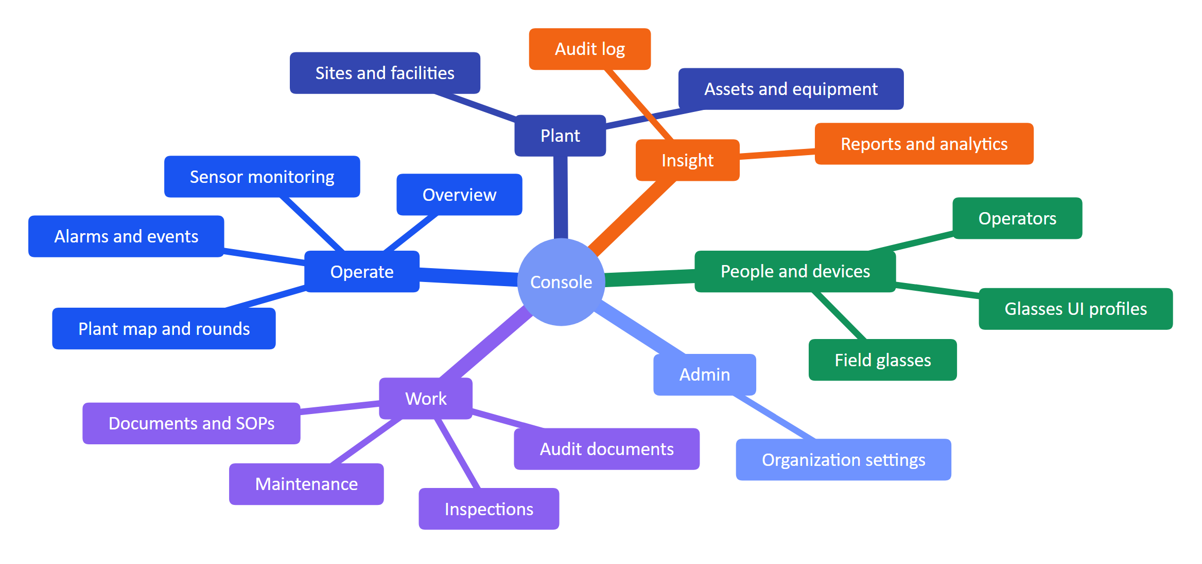
Figure 16. Console information architecture (navigation groups in Shell.tsx)
Navigation items are filtered by permission (perm on each NavItem), so an operator never sees a module they cannot open. The command palette searches assets, sensors, documents and people from every page.
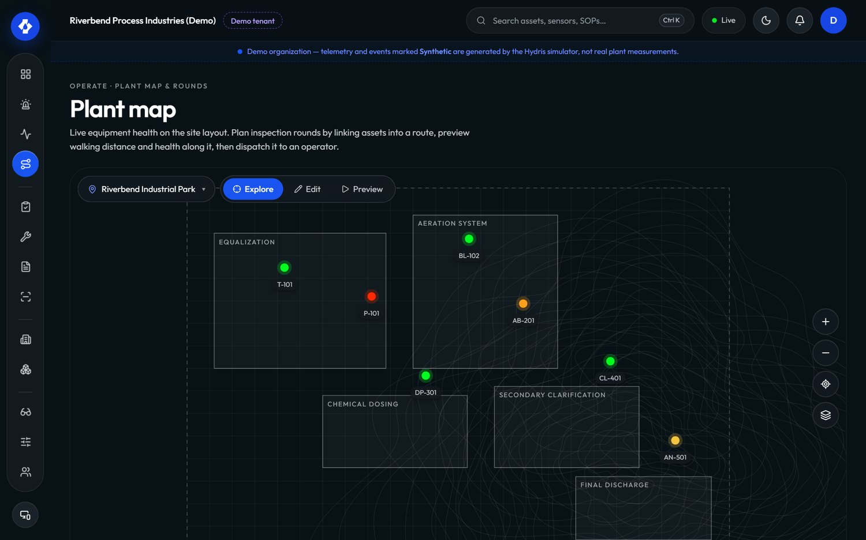
Figure 17. Console plant map and rounds
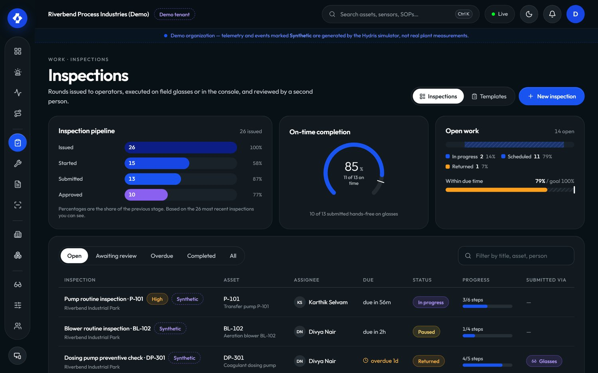
Figure 18. Console inspections
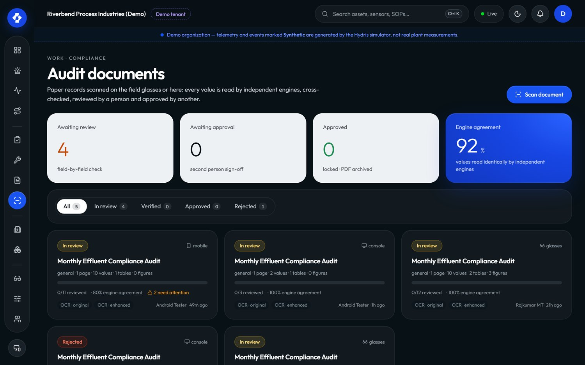
Figure 19. Console audit documents: review and approval of scanned records

10.2 Glasses app information architecture
The glasses app is a stack: Home is the root, every selection pushes a screen, and Back pops. Screens are gated by the UI profile (screenAllowed logic at the top of GlassesApp.tsx).
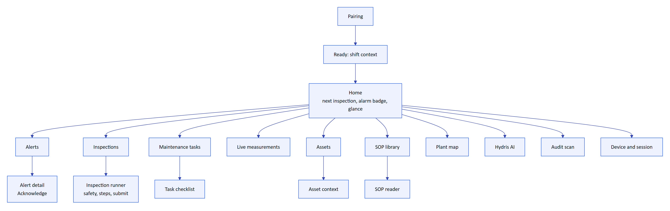
Figure 20. Glasses app navigation stack (profile-gated screens)

10.3 Android app navigation
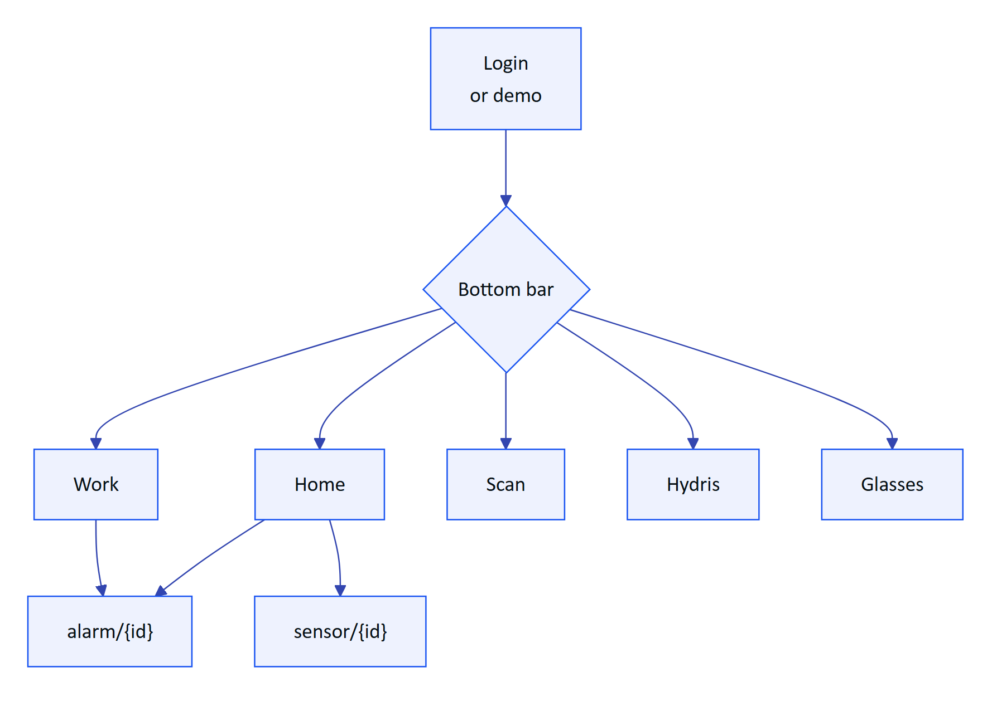
Figure 21. Android app navigation (ui/Root.kt)
Tab switches pop to Home with saved state and launchSingleTop, so returning to a tab restores its scroll position. Detail screens show a back arrow at top left (Icons.AutoMirrored.Outlined.ArrowBack), and the system back gesture works everywhere.
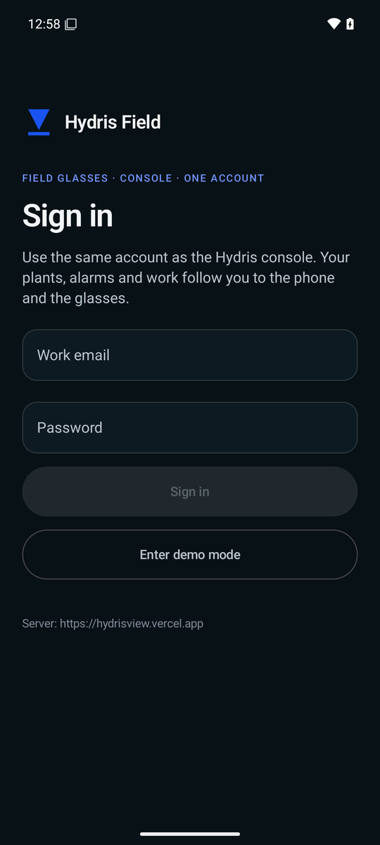
Figure 22. Android login
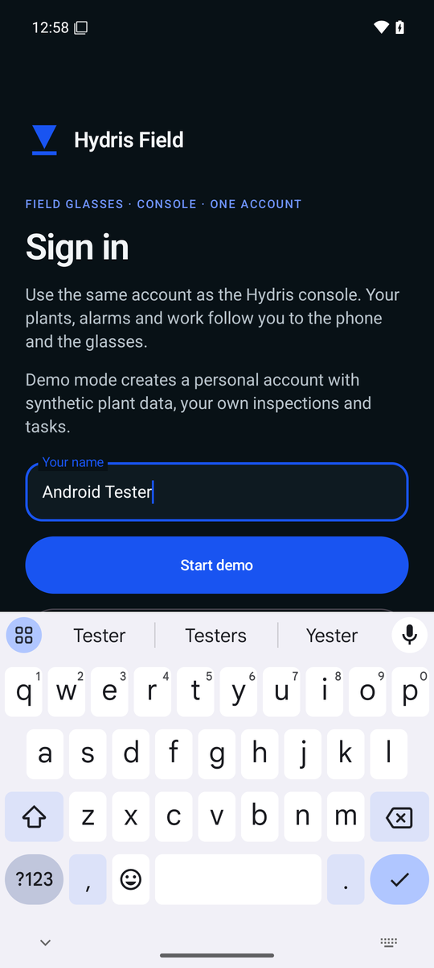
Figure 23. Android demo sign-in: choose a display name

11 Interaction patterns

11.1 Input model
The glasses app reduces every input to six keys: up, down, left, right, select, back (apps/web/src/glasses/input.ts). Keyboard arrows, Enter or Space, Escape or Backspace, touch swipes of at least 40 px, and simulator postMessage controls all map onto that vocabulary. Hardware gestures (neural band pinch and swipe, frame touchpad) plug in once their delivery to the web runtime is verified on a device (Planned). Phone mode adds direct touch on rows and the bottom tab bar.
Table 26. Input vocabulary and its meaning
Key | HUD meaning | Phone mode | Android
Up / Down | Move focus between HudItems; change a digit in numeric entry | Swipe up or down | Scroll
Left / Right | Move between digits; right also opens | Swipe right to open, left for back | n/a
Select | Activate focused item | Tap | Tap
Back | Pop the stack; dismiss interrupt | Back tab or swipe left | Back arrow or system back
Voice | "Hey Hydris" | Hey Hydris tab | Mic toggle on Hydris tab
Capture button | n/a on display glasses | n/a | Ray-Ban Meta short press triggers a scan capture

11.2 Voice first: "Hey Hydris"
The wake phrase is matched by WAKE_RE in packages/domain/src/voice.ts, which tolerates common mishearings ("hey hydras", "ok hydrus", "hi dris"). A question can follow in the same breath ("Hey Hydris, what's the pH?"). Answers come from the account's live data through POST /assistant/ask, are shown as a card and spoken through the glasses speakers or the device's speech synthesis (VoiceAssistant.tsx).
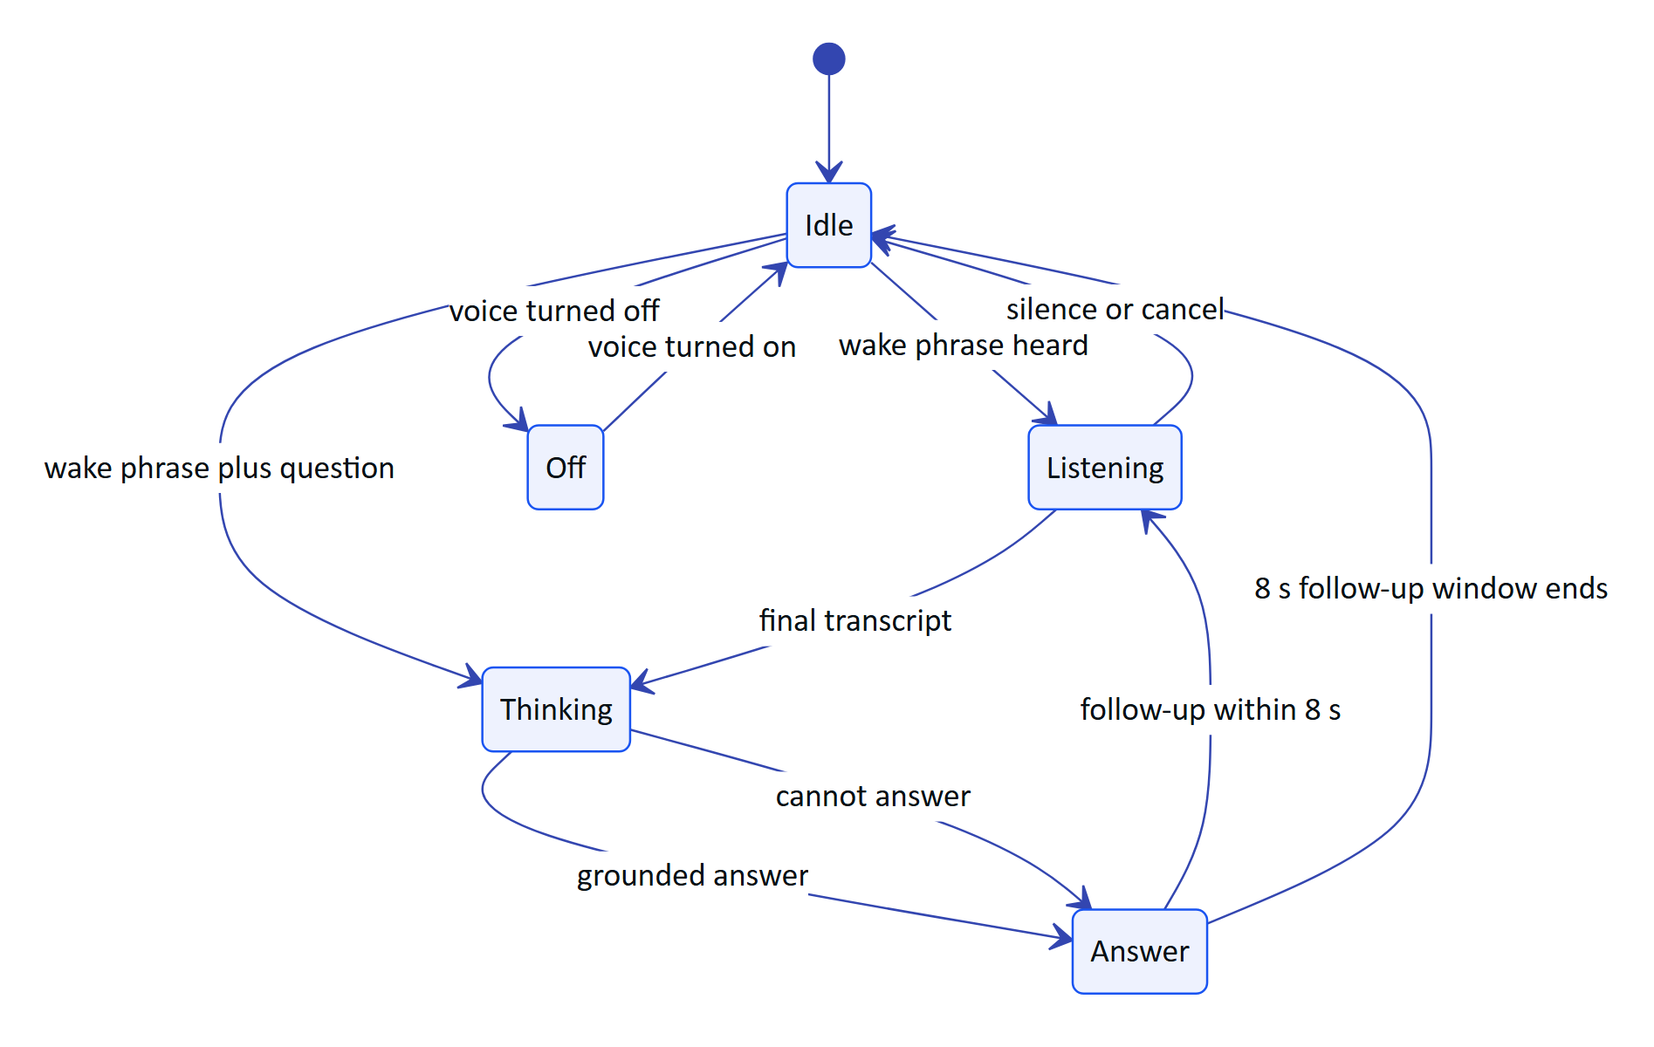
Figure 24. Hey Hydris voice states (VoiceAssistant.tsx)
Design rules for voice:
- Always show what was heard (Android renders the transcript in SignalText quotes) before the answer arrives.
- The thinking state has copy ("Checking your plant data…") so silence is never ambiguous.
- Answers list their facts with value, unit and label, so the operator can check the source.
- The mic state is always visible: "Hey Hydris" (listening for wake), "Voice off", "No mic" (VoiceAssistant.tsx).
- Voice never performs a state change on its own. Acknowledging or submitting stays an explicit select or tap.
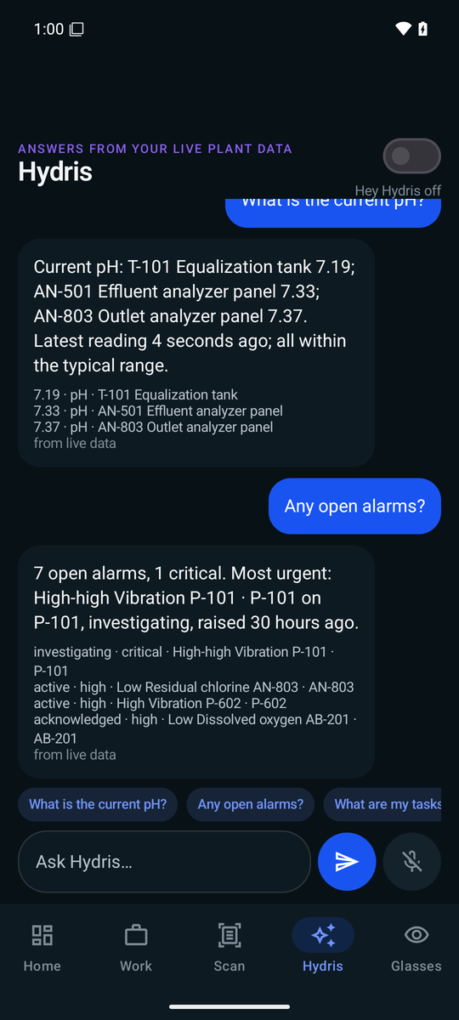
Figure 25. Android Hydris assistant: grounded answer with facts

11.3 Capture button and audit scan
On Ray-Ban Meta glasses the physical capture button is surfaced through the Meta Wearables Device Access Toolkit: a SHORT_PRESS capture event is emitted on GlassesManager.captureButton and the scan screen uses it to capture a page (apps/android/.../glasses/GlassesManager.kt). The scan menu offers three sources: glasses camera, phone camera with guided A4 framing, and photo import (ScanScreen.kt).
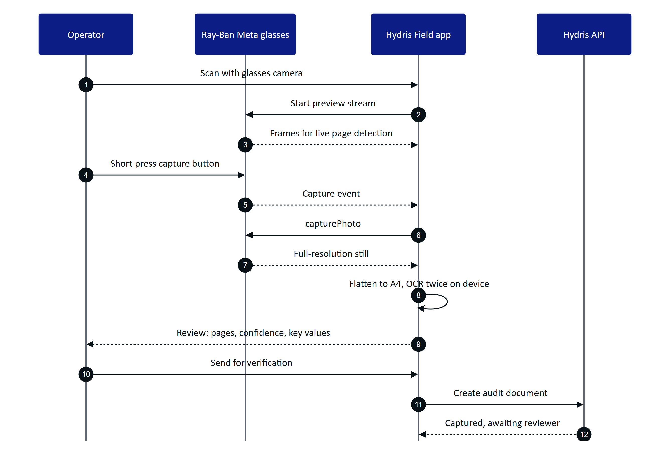
Figure 26. Audit scan with the glasses capture button
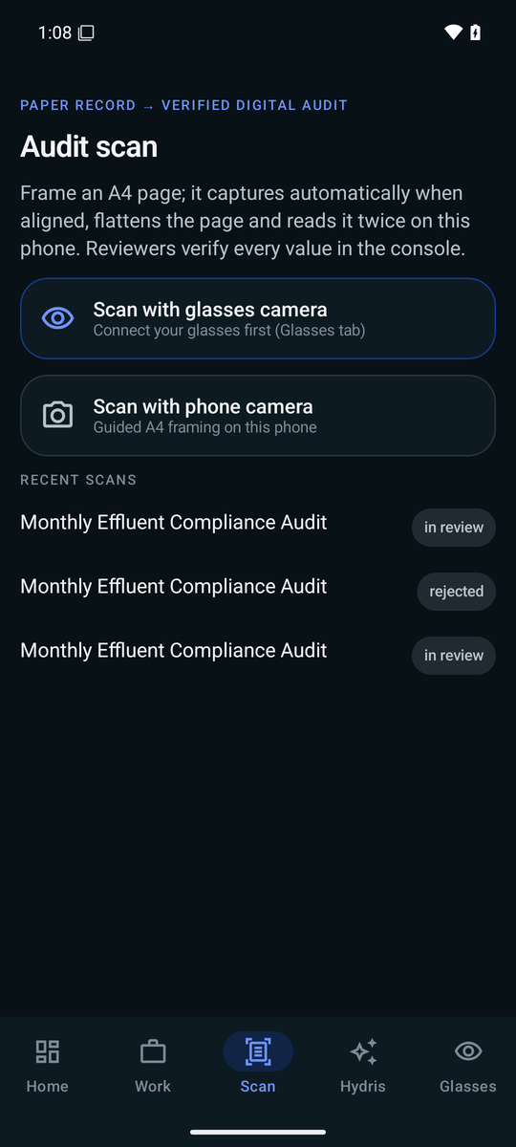
Figure 27. Android scan menu: glasses camera, phone camera or import

11.4 Guided capture feedback
GuidedCapture (apps/web/src/lib/GuidedCapture.tsx, with logic in lib/docdetect.ts; ported to Kotlin in apps/android/.../scan/DocDetect.kt) shows one instruction at a time. Detection runs every 90 ms; the detected sheet is outlined in Signal Blue while guidance is pending, in orange #FF6A3D when it touches the edge or is skewed, and in Active Green once ready. After 900 ms of continuous readiness it captures automatically.
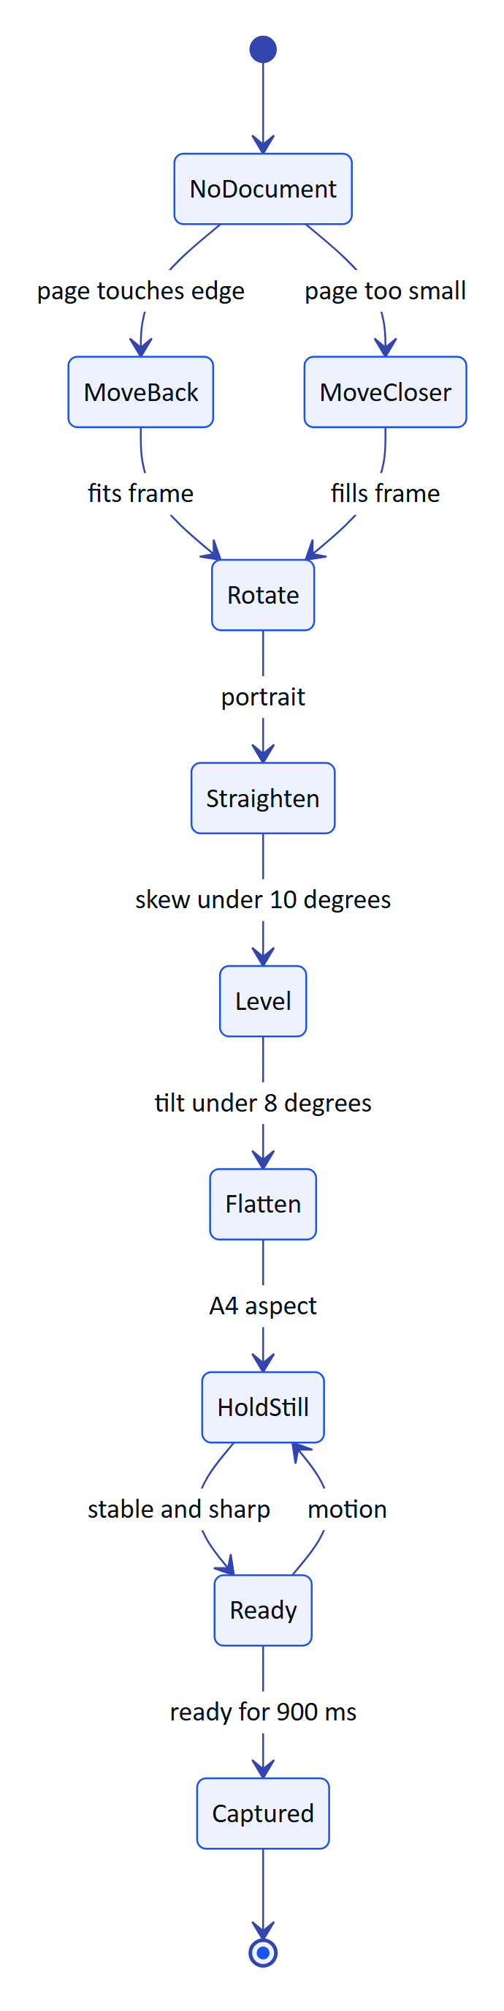
Figure 28. Guided A4 capture guidance (docdetect.ts guide function)
Table 27. Guidance messages (lib/docdetect.ts)
Code | Message shown | Outline colour
no_document | Place the A4 sheet in view, on a dark surface | None
move_back | Move back - show all four corners of the page | Orange
move_closer | Move closer - fill the frame with the page | Signal Blue
rotate | Turn the sheet to portrait (long side vertical) | Signal Blue
straighten | Look straight down at the page - reduce the tilt | Orange
level | Level the page - rotate it left or right until upright | Orange
flatten | Hold the sheet flat and square to your view | Signal Blue
hold_still | Hold still… | Signal Blue
ready | Perfect - capturing | Active Green, with fill progress

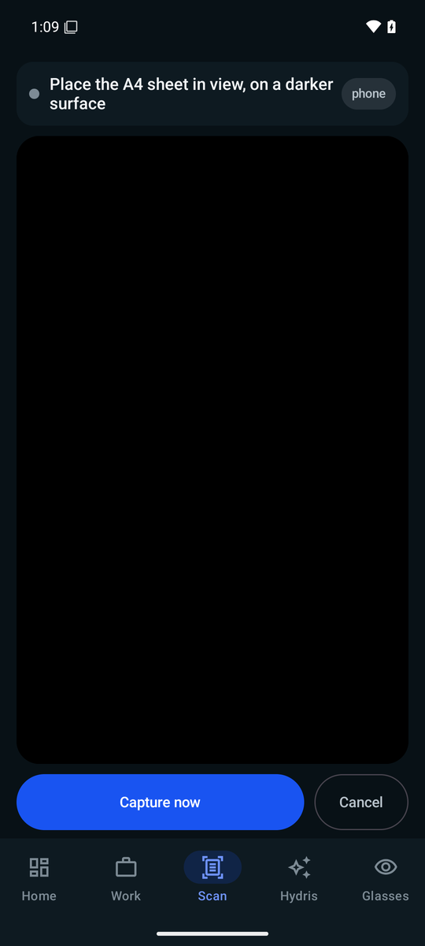
Figure 29. Android guided capture: live outline and single instruction
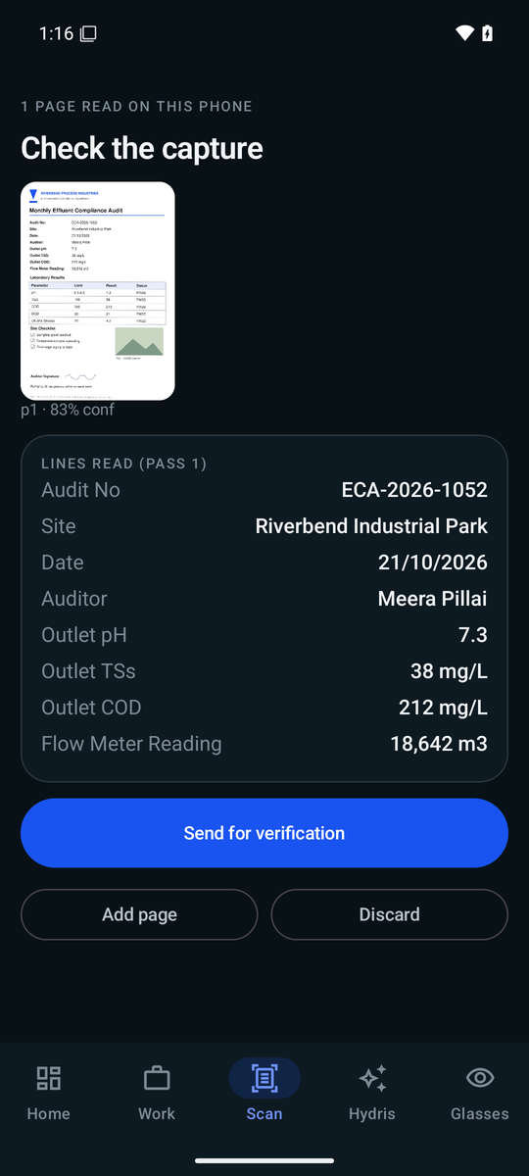
Figure 30. Android scan review: pages, confidence and detected values
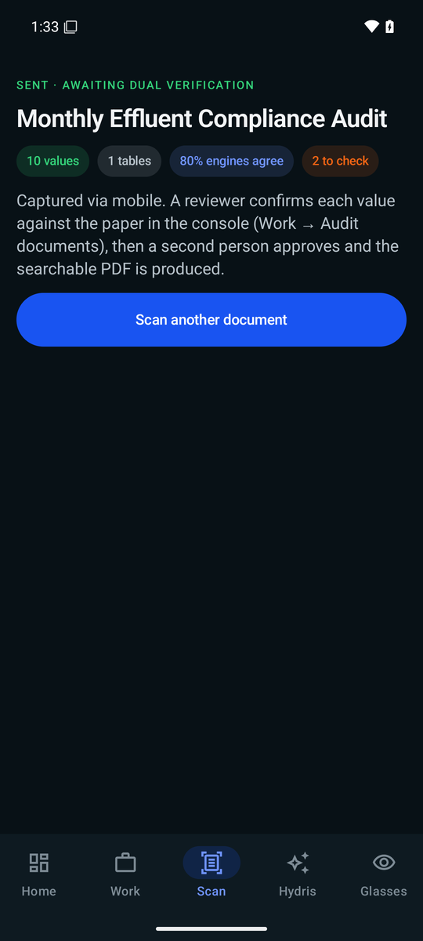
Figure 31. Android scan sent: next steps for reviewer and approver

11.5 Back navigation
- HUD: Back key or swipe left pops one screen; a Back pill sits bottom left when the stack is deeper than Home.
- Phone mode: the first tab becomes Back whenever the stack is deeper than Home, otherwise Home (PhoneTabBar). This keeps back reachable with a thumb at the bottom of the screen.
- Android: top-left back arrow on detail screens and the system back gesture.
- Console: breadcrumbs and BackLink; ErrorState defaults back to the parent list.
- Back never discards recorded work: inspection steps are saved as they are recorded and queued offline.

11.6 Alarm acknowledgement and lifecycle
The alarm lifecycle is defined once in packages/domain/src/alarms.ts and enforced by the API. Each surface shows only the next valid actions.
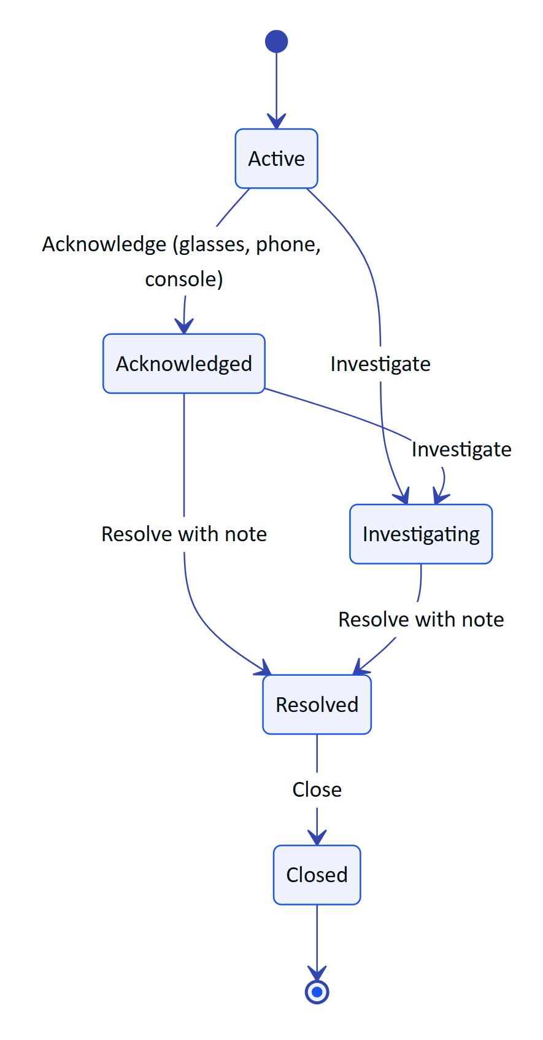
Figure 32. Alarm lifecycle and the actions each surface offers
Table 28. Acknowledgement and lifecycle patterns by surface
Surface | Interrupt | Acknowledge | Resolve | Status
Glasses HUD | AlertInterrupt full-screen overlay for critical and high, View or Dismiss | Single focused HudItem, disabled offline with "(needs connection)" | Not offered (console or phone) | Built
Android | None (push notifications Planned) | Full-width primary button | Button shown, but no note is collected | Partial
Console | Realtime toast for critical alarms | Button on detail | ConfirmDialog with required note "What was done to resolve the condition" | Built

WARNING
On Android the Resolve button posts the action without a note (WorkScreen.kt calls alarmAction(id, "resolve")), but the API rejects resolve without one (note_required in apps/api/src/modules/alarms.ts). The operator sees an error note. Fix: a bottom sheet that collects the note, matching the console's ConfirmDialog. Status: Planned.

11.7 Operator experience journey
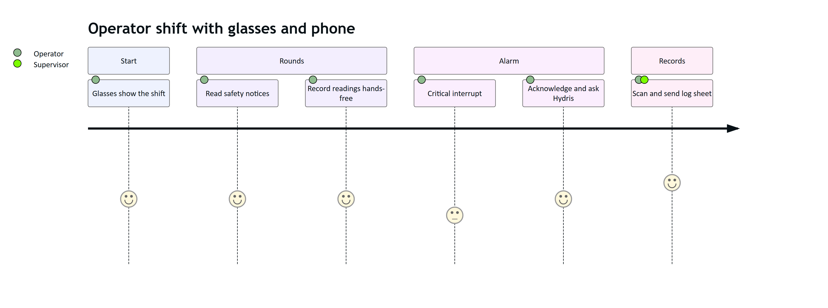
Figure 33. Field operator shift journey with Hydris (target experience)
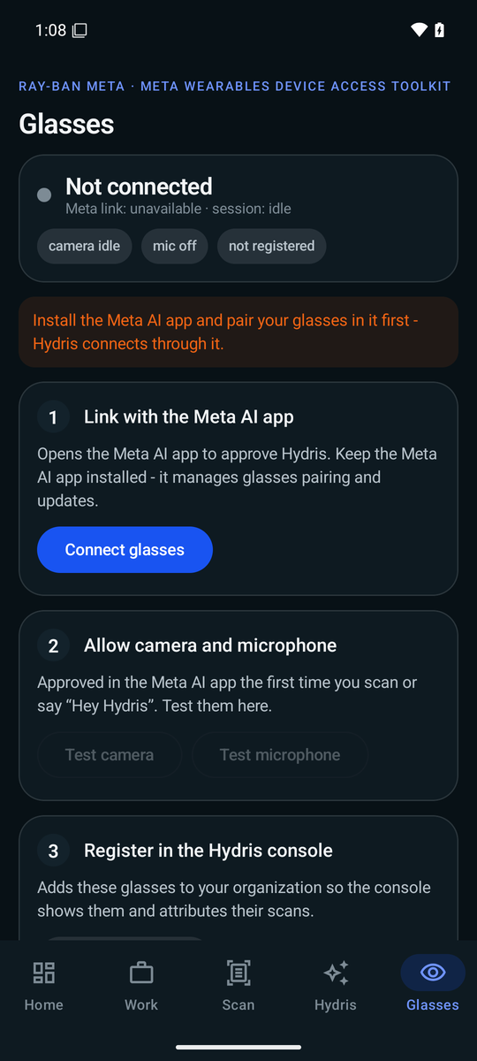
Figure 34. Android glasses screen: connection checklist and registration

12 Motion
Motion explains change; it never decorates. All motion tokens are in globals.css.
Table 29. Motion tokens and patterns
Token or class | Value | Use
--speed-fast | 150 ms | Colour and border changes, press feedback
--speed | 240 ms | Lifts, fades
--ease-out | cubic-bezier(0.22, 1, 0.36, 1) | Default easing
--ease-spring | cubic-bezier(0.34, 1.4, 0.64, 1) | Theme toggle icon only
.page-enter | 360 ms fade and 8 px rise | Route change in console
.pop-in | 220 ms | Popovers, centred dialogs
.sheet-up | 320 ms | Bottom sheets
.slide-in-right | 320 ms | Side panels
.stagger | 40 ms steps up to 200 ms | Card grids on load
.pulse-dot | 1.8 s | Live freshness dot only
.skeleton | 1.6 s shimmer | Loading
Chart transitions | 600 to 700 ms | Bars and arcs growing to value
Theme switch | 300 ms colour cross-fade | html.theme-switching

Rules:
- prefers-reduced-motion: reduce disables animations and transitions globally, stops the pulse dot and hides the toast timer (globals.css). Built on web.
- The HUD uses colour transitions only; no movement on an additive display, where motion pulls the eye from the task. Built.
- Android uses Material defaults; honouring the system "remove animations" setting is inherent to Compose animation APIs. Custom motion is not used. Built.
- Alarms never animate in a way that could be mistaken for normal motion; the interrupt simply appears.

13 Accessibility

13.1 Targets
Table 30. Accessibility targets
Area | Target | Status
Text contrast | WCAG 2.2 AA (4.5:1, 3:1 large) on every surface and theme | Partial (3 failures listed in the contrast audit)
Non-text contrast | 3:1 for borders of inputs, focus rings, chart marks | Built (focus ring #6F93FF 6.62:1 on bg)
Target size | WCAG 2.5.8: at least 24 by 24 px; Hydris standard 44 by 44 px | Built on web (::after hit areas on btn-sm, icon-btn-sm, chips, links) and Android (48 dp Material, 52 dp buttons)
Focus visible | 2 px outline, 2 px offset, colour follows surface | Built (:focus-visible in globals.css)
Keyboard | Every console action reachable by keyboard; HUD fully key-driven | Built
Screen readers | Labels on icon buttons; charts as images with text tables; live region for route changes | Built on web, Partial on Android charts
Forced colours | Selected capsule outlined in CanvasText | Built
Text resize | Web reflow to 320 px; Android sp; HUD textScale | Built
Reduced motion | Respect user preference | Built (web)
Haptics | Vibration for critical alarms and confirmed actions | Planned

13.2 Gloves, noise and outdoor light
- Gloves. Field targets are 52 dp or larger on Android task flows and the full width of the screen where possible; the phone-mode tab bar is 92 units tall with 28-unit icons. Avoid swipe-only actions in phone flows: every swipe has a tap equivalent.
- Noise. Voice is a convenience, never the only path. Every voice capability has a button or tap equivalent, and answers are shown as text as well as spoken. On Ray-Ban Meta glasses the microphone is the glasses microphone over Bluetooth, which sits closer to the mouth than the phone.
- Outdoor light. Dark themes with near-white text (19:1) survive glare better than mid-grey palettes. Minimum sizes outdoors: 16 sp body on Android, 20 units body on the HUD, KPI values at 34 sp or larger. Operators can raise text size through the system setting (Android) or the UI profile (glasses).
- Safety glasses and polarised lenses. Do not rely on subtle tints; severity is always paired with a word and, on the HUD, a 2 to 3 unit border.

13.3 Haptics (Planned)
No haptic feedback exists in the code today (no vibration calls on web or Android). The planned pattern: one short pulse when a step is recorded, a double pulse when an action is rejected, and a long pulse for a critical alarm interrupt on Android. Haptics complement, never replace, visible state.

14 Content and voice guidelines
Hydris copy is short, specific and calm. It names the equipment, the value and the next step. It never overstates what the system does.
Table 31. UX writing do and don't
Do | Don't | Why
"Acknowledge" with hint "does not change equipment" | "Fix", "Clear alarm" | Hydris records; it does not operate equipment
"VT-101 vibration high-high · 7.4 mm/s" | "Problem detected on pump" | Name the tag, measurand and value
"Offline · showing data cached 4m ago" | "Error" | Say what still works and how old the data is
"Next step (approved procedure): ..." | "AI recommends ..." | Attribute guidance to the approved SOP
"Send for verification" | "Submit final" | A reviewer and approver still confirm the record
"We couldn't find that record" plus a way back | "404 Not Found" | Plain language with a recovery path
"Ticking checklist items · not permitted by your profile" | Hiding the control silently | Never hide state
"Checking your plant data…" | Silent spinner | Explain waits longer than a moment
"Synthetic" | "Test", "Fake" | Consistent term for simulator data
"Step 3 of 8 · optional" | "Question 3" | Orientation and obligation in one line

Rules:
- Sentence case for every label and title. Uppercase only through the eyebrow style.
- Units follow numbers with a space ("7.4 mm/s"); pH is the exception and leads the value ("pH 6.8").
- Relative times for recent events ("5m ago"), absolute times in tooltips and audit records.
- No em dashes in product copy or documents; use a colon, a comma, a middle dot or two sentences. The guided capture messages currently use a spaced hyphen, which is acceptable on screen.
- Button labels are verbs; one to three words on the HUD.

15 Localisation
The product ships in English only today: the web root sets lang="en" (apps/web/src/app/layout.tsx) and no string catalogue or i18n library exists on web or Android.
Table 32. Localisation plan
Item | Detail | Status
String extraction | Web: message catalogues per route; Android: strings.xml resources | Planned
Hindi (hi-IN) | First additional language; Devanagari font fallback for Outfit (Noto Sans Devanagari) | Planned
Tamil (ta-IN), Marathi, Gujarati, Telugu, Kannada | Pilot regions in India | Planned
Voice | Wake phrase stays "Hey Hydris"; recognition and TTS locale follow the operator | Planned
OCR | ML Kit Devanagari model for Hindi labels on audit sheets (per mobile spec) | Planned
Numbers and units | Locale digit grouping in tables; SI units unchanged; decimal separator follows locale | Planned
Layout tolerance | Labels must survive 40 % expansion; HUD rows truncate with an ellipsis, never wrap into two actions | Rule (applies now)

NOTE
Indic scripts need taller line heights than Latin. When Hindi or Tamil is added, HUD row padding and the 0.95 line height of t-kpi must be rechecked; numerals stay Latin (tabular) in every locale.

16 Dark and light themes
Table 33. Theme support by surface
Surface | Default | Light theme | Mechanism | Status
Console | Dark | Full token set | data-theme on <html> set by a blocking script before paint; ThemeToggle (system, light, dark); stored in localStorage key hydris.theme | Built
Website | Dark | Shared tokens plus .hx brand layer | Same | Built
Glasses app and simulator viewport | Dark, forced | None (by design) | FORCED_DARK_RE | Built
Android | Dark | None | darkColorScheme only | Planned (light scheme for office use)
Word and PDF documents | Light | n/a | Build theme | Built

Rules: the blue focal panel, brand blue fills and Alert Orange are identical in both themes; semantic text tints are redefined for light so they stay AA (for example critical text #C41F00 on white, 5.93:1); KPI accent numerals deepen on paper and light surfaces (kpi-accent-* overrides).
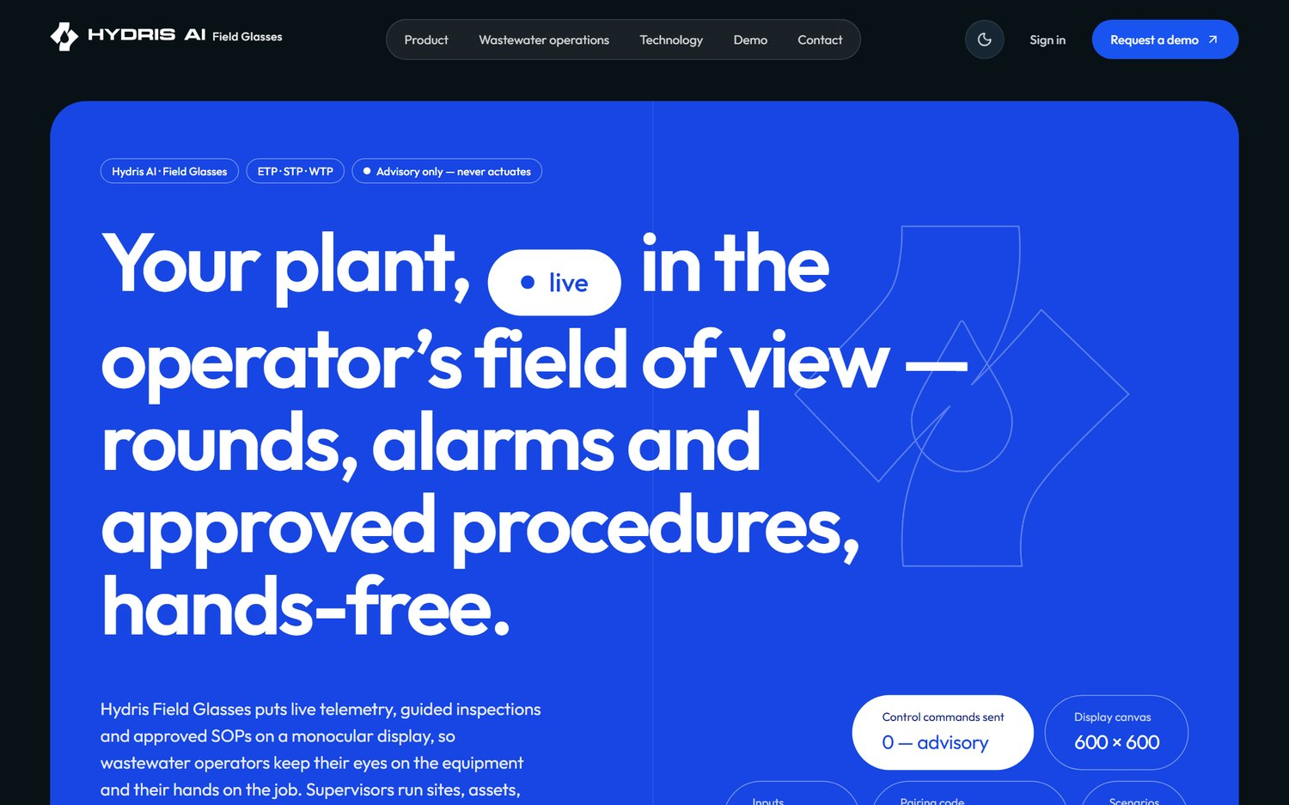
Figure 35. Website home: brand layer over the shared tokens

17 Design QA checklist
Use this list on every pull request that changes UI. Items checked here are true of the current code base; open items are known gaps to close.
- ☑ Uses semantic tokens only; no new hex values in components (web)
- ☑ Every value shows unit and freshness, and missing data shows "No data"
- ☑ Severity is shown with a word or icon as well as colour
- ☑ Synthetic data carries the Synthetic marker on every surface
- ☑ Interactive targets are at least 44 by 44 px (web) or 48 dp (Android)
- ☑ Focus is visible and follows the surface colour
- ☑ Charts have an accessible name and an empty state (web)
- ☑ prefers-reduced-motion respected (web)
- ☑ HUD screen has one column and one primary action
- ☑ Blocked actions are explained, not hidden (glasses)
- ☐ HUD selected pill, View button and digit cell use white ink on Signal Blue (contrast 5.87:1)
- ☐ Android filled severity chips meet 4.5:1 or use the tinted style
- ☐ Android synthetic chip uses a lighter Insight text tint
- ☐ Android Resolve collects a note before posting
- ☐ High severity colour aligned to #F26414 across console, website, Android and HUD
- ☐ HUD severity colours moved from inline hex to tokens
- ☐ Android chart canvases have content descriptions
- ☐ Haptic patterns implemented for record, reject and critical alarm
- ☐ Strings extracted for localisation
- ☐ Tested at UI profile text scale 1.3 in both densities and both hands

18 Governance and contribution
The design system is owned by Design, Hydris, with one engineering maintainer per platform (web, Android). Changes follow the same review discipline as code: the Markdown in this folder and the token files are the source of truth.
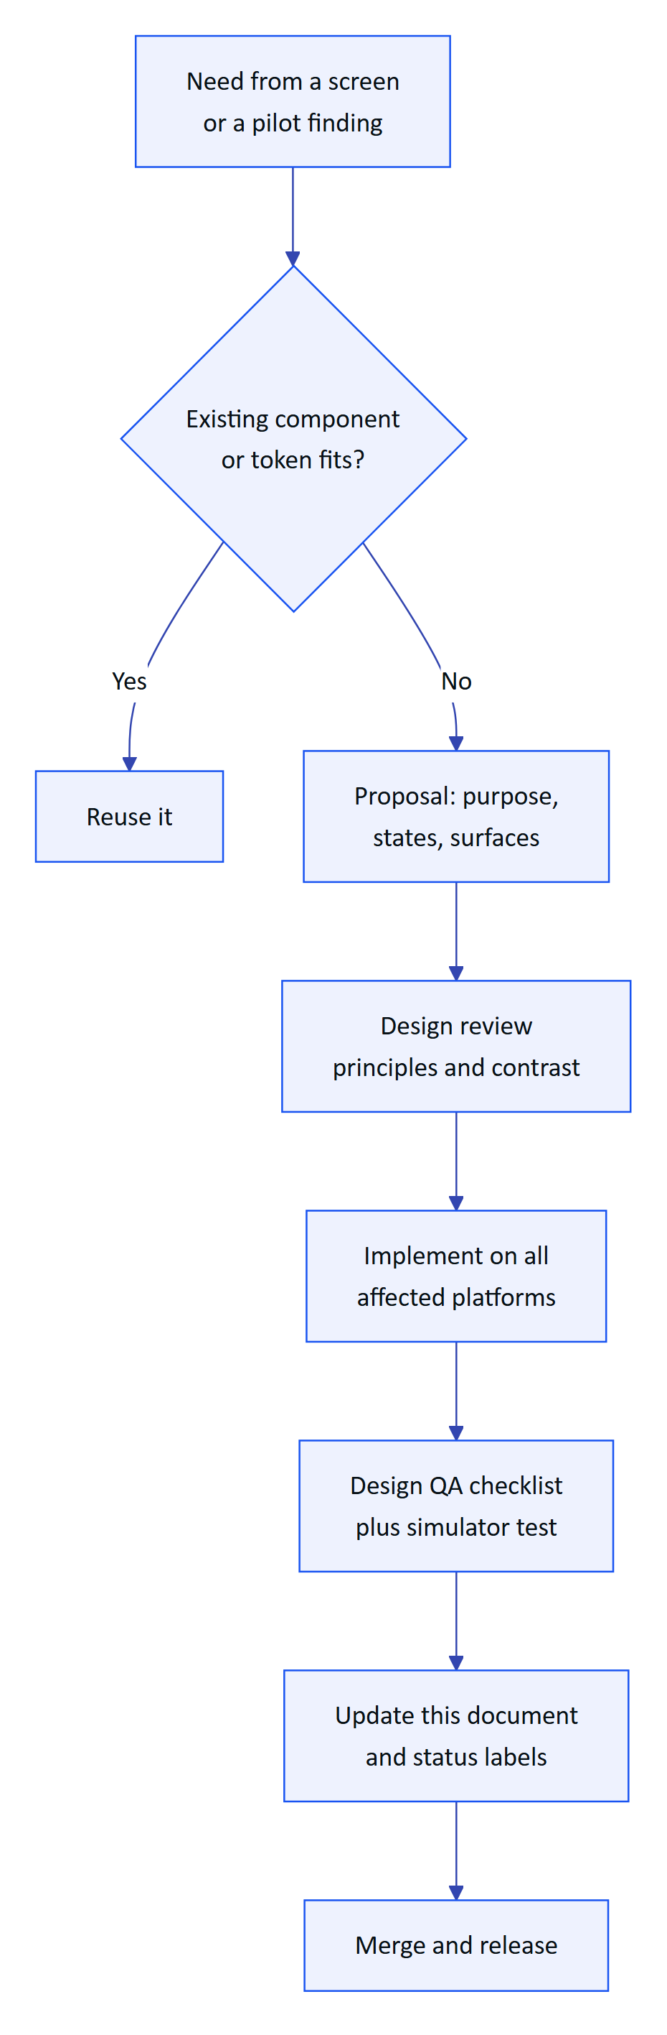
Figure 36. Contribution process for a design system change
Table 34. Contribution rules
Rule | Detail
Tokens before components | A new colour, size or radius is added as a token in globals.css and Theme.kt (and the HUD) in the same pull request
No one-off severity colours | Severity and status colours come only from the severity tokens
All surfaces or a ticket | A change to a shared pattern ships on every surface, or opens a tracked gap with a Partial label here
Contrast proof | New colour pairs include their computed ratio in the pull request description
Simulator check | Glasses changes are checked in the simulator at 600 by 600, 640 by 480 and 480 by 480, in phone mode, and at text scale 1.3
Screenshots | Updated screenshots go into docs/product/images/ (web shots refresh with node screenshots.js)
Versioning | This document versions with minor bumps for additions and major bumps for breaking token renames

19 Future work
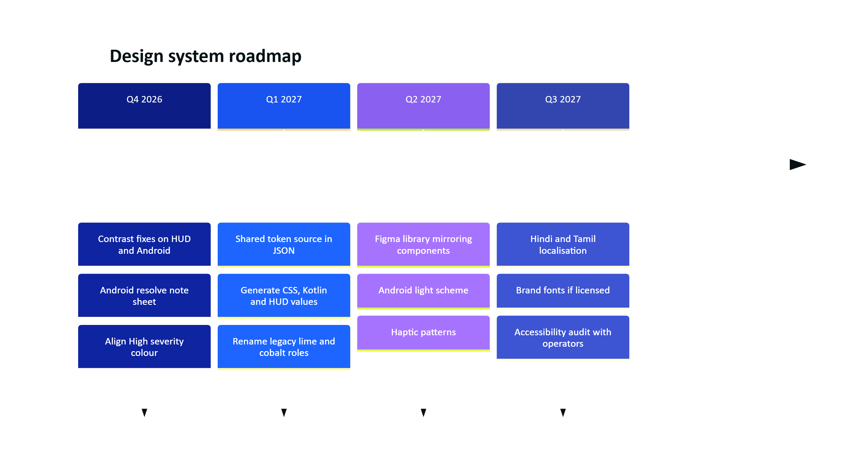
Figure 37. Design system roadmap (targets, not commitments)
Table 35. Future work items
Item | Description | Status
Token pipeline | One JSON token source (for example in packages/domain or a new packages/tokens) that generates globals.css variables, Theme.kt Hx and a HUD palette module | Planned
Figma library | Components, tokens as Figma variables, HUD frame templates at 600 by 600 and phone 540-unit width, linked to code | Planned
Legacy role renames | lime to signal, cobalt to purple across classes and utilities | Planned
Android component parity | StateChip, FreshnessBadge, empty states and a severity chip that matches the web | Planned
Push notification design | Critical alarm notification layout and channels on Android | Planned
Hardware gesture mapping | Neural band and frame touchpad onto the six-key vocabulary | Planned
Field usability study | Glove, glare and noise trials with pilot operators; results to update this document | Planned

EXAMPLE
A token entry in the planned pipeline: color.severity.high = { value: "#F26414", text.dark: "#FF9A5C", text.light: "#A35200" } generates --color-high and --color-high-text for web, Hx.High and Hx.HighText for Android, and the HUD pill and border values, so one change updates every surface.

